Supporting Information
Bioorg. Med. Chem. Rep. X:X (202X) XX-XX
Two novel sesquiterpenes and a new pregnane derivative from Subergorgia suberosa

Xian-Qiang Chen ^{1, 2}, Nannan Xing³, Bin Yang ², Xuefeng Zhou ², Chenghai Gao ¹ and Yonghong Liu ^{1, 2 ∗}
¹ Institute of Marine Drugs, Guangxi University of Chinese Medicine, Nanning, Guangxi 530200, P. R. China
² Key Laboratory of Marine Bio-resources Sustainable Utilization; Guangdong Key Laboratory of Marine Materia Medica; Research Center for Marine Microbes, South China Sea Institute of Oceanology, Chinese Academy of Sciences, Guangzhou, Guangdong 510301, P. R. China
³ Guangxi Key Laboratory of Chinese Medicine Foundation Research, Guangxi Scientific Experimental Center of Traditional Chinese Medicine, Guangxi University of Chinese Medicine, Nanning, Guangxi 530200, P. R. China

Table of Contents | Page
Figure S1: HR-ESI-MS Spectrum of 1 (isosuberosenol A) | 3
Figure S2: ¹H-NMR (500 MHz, CDCl₃) Spectrum of 1 (isosuberosenol A) | 4
Figure S3: ¹³C-NMR (125 MHz, CDCl₃) Spectrum of 1 (isosuberosenol A) | 5
Figure S4: DEPT135 (125 MHz, CDCl₃) Spectrum of 1 (isosuberosenol A) | 6
Figure S5: HSQC Spectrum of 1 (isosuberosenol A) | 7
Figure S6: HSQC Spectrum of 1 (isosuberosenol A) (From δ_{C}15 ppm to δ_{C} 35 ppm) | 8
Figure S7: HMBC Spectrum of 1 (isosuberosenol A) | 9
Figure S8: HMBC Spectrum of 1 (isosuberosenol A) (From δ_{C} 79 ppm to δ_{C} 85 ppm ) | 10
Figure S9: HMBC Spectrum of 1 (isosuberosenol A) (From δ_{C} 38 ppm to δ_{C} 53 ppm ) | 11
Figure S10: HMBC Spectrum of 1 (isosuberosenol A) (From δ_{C} 15 ppm to δ_{C} 36 ppm ) | 12
Figure S11: ¹H-¹H COSY Spectrum of 1 (isosuberosenol A) | 13
Figure S12: NOESY Spectrum of 1 (isosuberosenol A) | 14
Figure S13: HR-ESI-MS Spectrum of 2 (suberosain A) | 15
Figure S14: ¹H-NMR (500 MHz, CDCl₃) Spectrum of 2 (suberosain A) | 16
Figure S15: ¹³C-NMR (125 MHz, CDCl₃) Spectrum of 2 (suberosain A) | 17
Figure S16: DEPT135 (125 MHz, CDCl₃) Spectrum of 2 (suberosain A) | 18
Figure S17: HSQC Spectrum of 2 (suberosain A) | 19
Figure S18: HSQC Spectrum of 2 (suberosain A) (From δ_{C} 14 ppm to 50 ppm) | 20
Figure S19: HMBC Spectrum of 2 (suberosain A) | 21
Figure S20: HMBC Spectrum of 2 (suberosain A) (From δ_{C} 52 ppm to 75 ppm) | 22
Figure S21: HMBC Spectrum of 2 (suberosain A) (From δ_{C} 15 ppm to 50 ppm) | 23
Figure S22: ¹H-¹H COSY Spectrum of 2 (suberosain A) | 24
Figure S23: NOESY Spectrum of 2 (suberosain A) | 25
Figure S24: HR-ESI-MS Spectrum of 3 (4-hydroxymethyl-5β-pregnan-3, 20-dione) | 26
Figure S25: ¹H-NMR (500 MHz, CDCl₃) Spectrum of 3 (4-hydroxymethyl-5β-pregnan-3, 20-dione) | 27
Figure S26: ¹³C-NMR (125 MHz, CDCl₃) Spectrum of 3 (4-hydroxymethyl-5β-pregnan-3, 20-dione) | 28
Figure S27: DEPT135 (125 MHz, CDCl₃) Spectrum of 3 (4-hydroxymethyl-5β-pregnan-3, 20-dione) | 29
Figure S28: HSQC Spectrum of 3 (4-hydroxymethyl-5β-pregnan-3, 20-dione) | 30
Figure S29: HSQC Spectrum of 3 (4-hydroxymethyl-5β-pregnan-3, 20-dione) (From δ_{C} 12 to 42) | 31
Figure S30: HMBC Spectrum of 3 (4-hydroxymethyl-5β-pregnan-3, 20-dione) | 32
Figure S31: HMBC Spectrum of 3 (4-hydroxymethyl-5β-pregnan-3, 20-dione) (From δ_{C} 42 to 70) | 33
Figure S32: HMBC Spectrum of 3 (4-hydroxymethyl-5β-pregnan-3, 20-dione) (From δ_{C} 12 to 40) | 34
Figure S33: ¹H-¹H COSY Spectrum of 3 (4-hydroxymethyl-5β-pregnan-3, 20-dione) | 35
Figure S34: NOESY Spectrum of 3 (4-hydroxymethyl-5β-pregnan-3, 20-dione) | 36

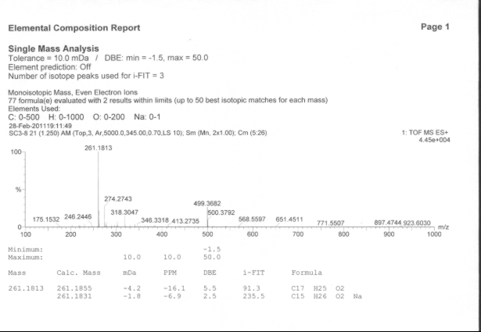
Figure S1: HR-ESI-MS Spectrum of 1 (isosuberosenol A)

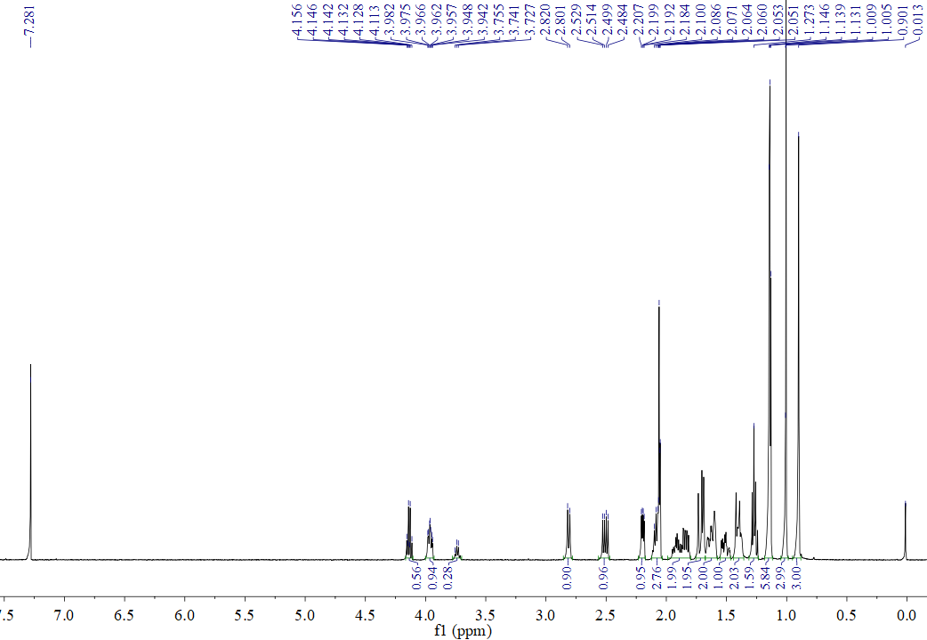
Figure S2: ¹H-NMR (500 MHz, CDCl₃) Spectrum of 1 (isosuberosenol A)

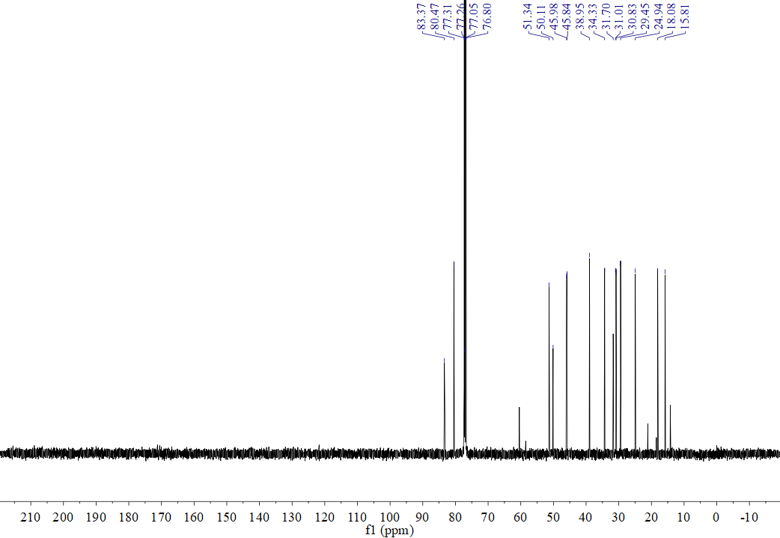
Figure S3: ¹³C-NMR (125 MHz, CDCl₃) Spectrum of 1 (isosuberosenol A)
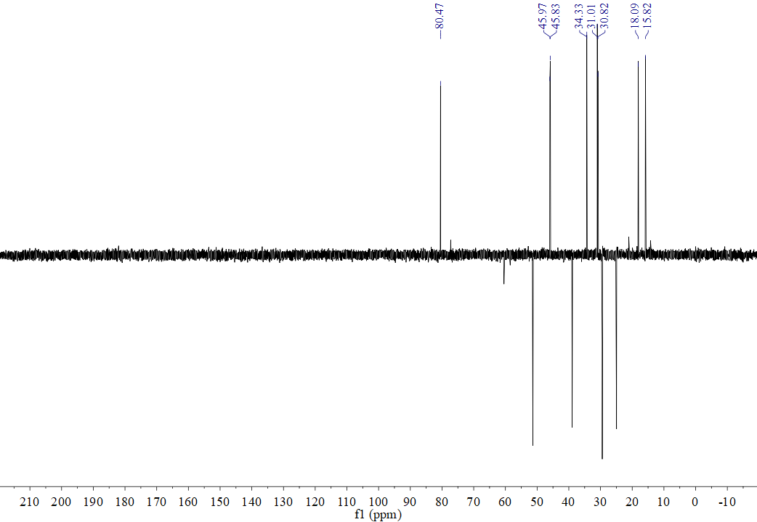
Figure S4: DEPT135 (125 MHz, CDCl₃) Spectrum of 1 (isosuberosenol A)

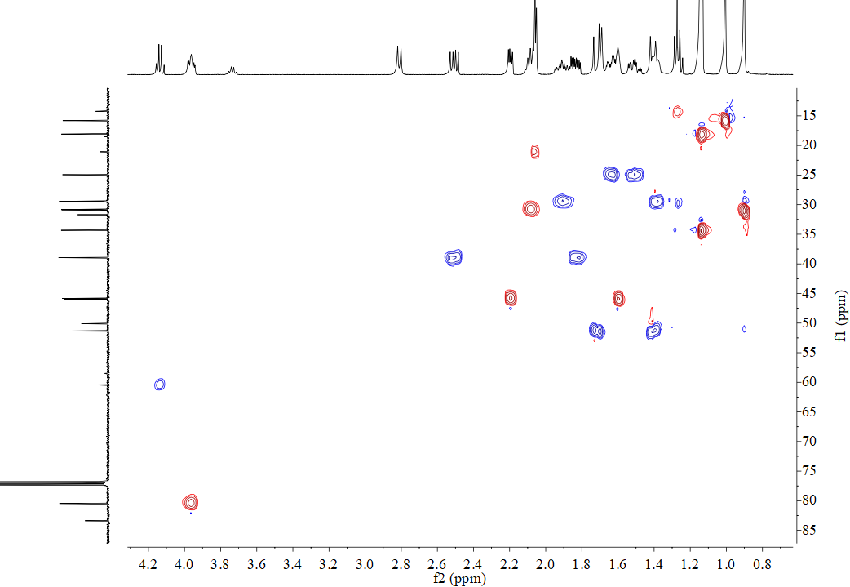
H4/C4
H3a/C3
H2/C2
H3b/C3
H11/C11
H12a/C12
H12b/C12
Figure S5: HSQC Spectrum of 1 (isosuberosenol A)
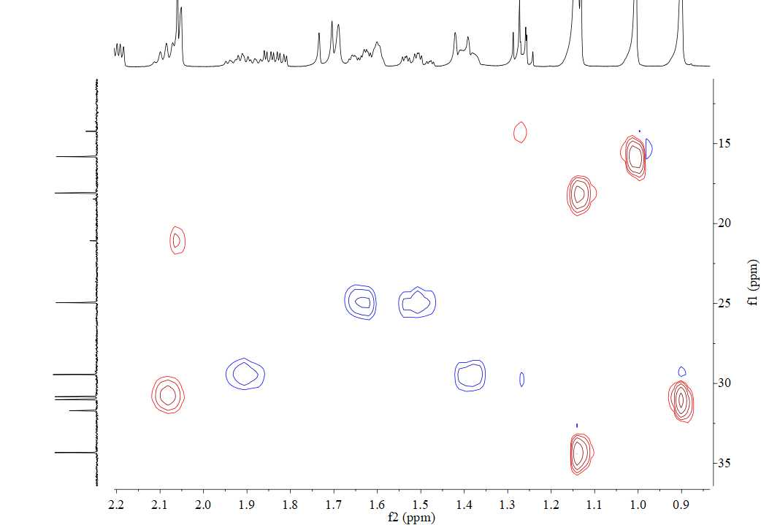
H6/C6
H10a/C10
H10b/C10
H9a/C9
H9b/C9
H15/C15
H7/C7
H14/C14
H8/C8
Figure S6: HSQC Spectrum of 1 (isosuberosenol A) (From δ_{C}15 ppm to δ_{C} 35 ppm)
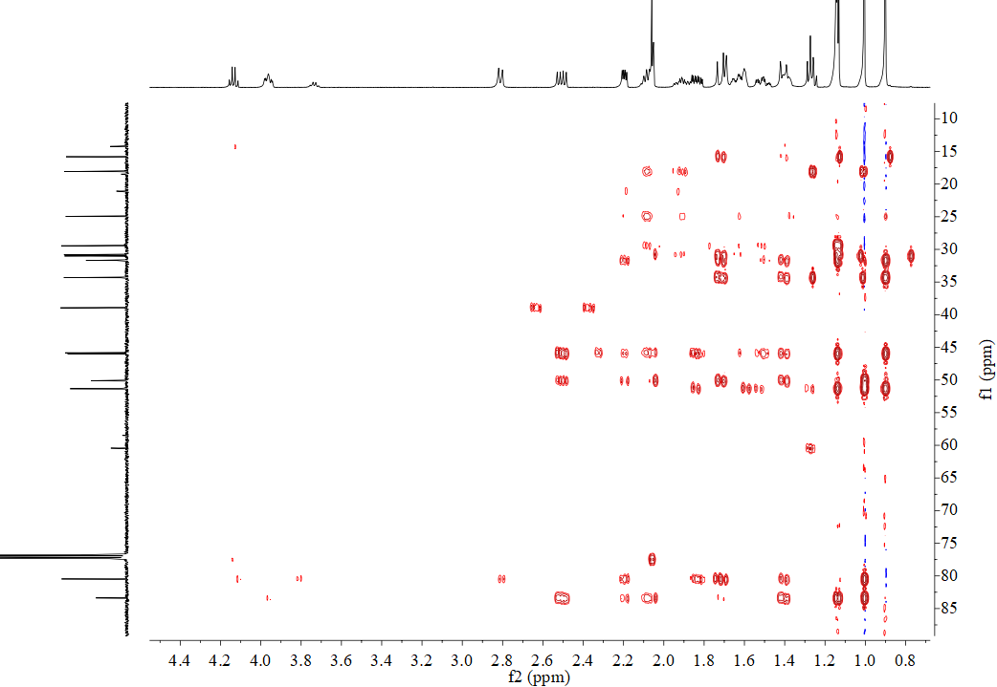
Figure S7: HMBC Spectrum of 1 (isosuberosenol A)
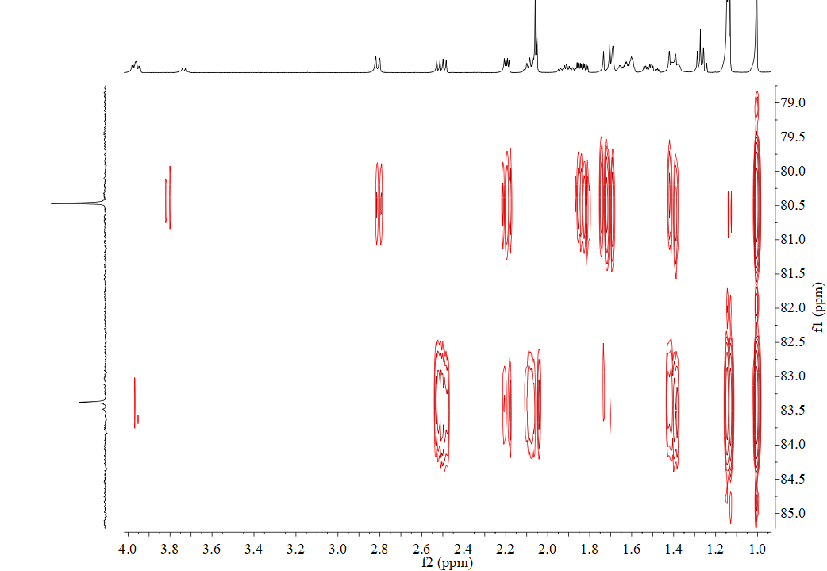
H2/C4
H12a/C4
H3b/C4
H12b/C4
H6/C4
H6/C4
H4/C1
H3a/C1
H2/C1
H8/C1
H12b/C1
H7/C1
H6/C1
Figure S8: HMBC Spectrum of 1 (isosuberosenol A) (From δ_{C} 79 ppm to δ_{C} 85 ppm )
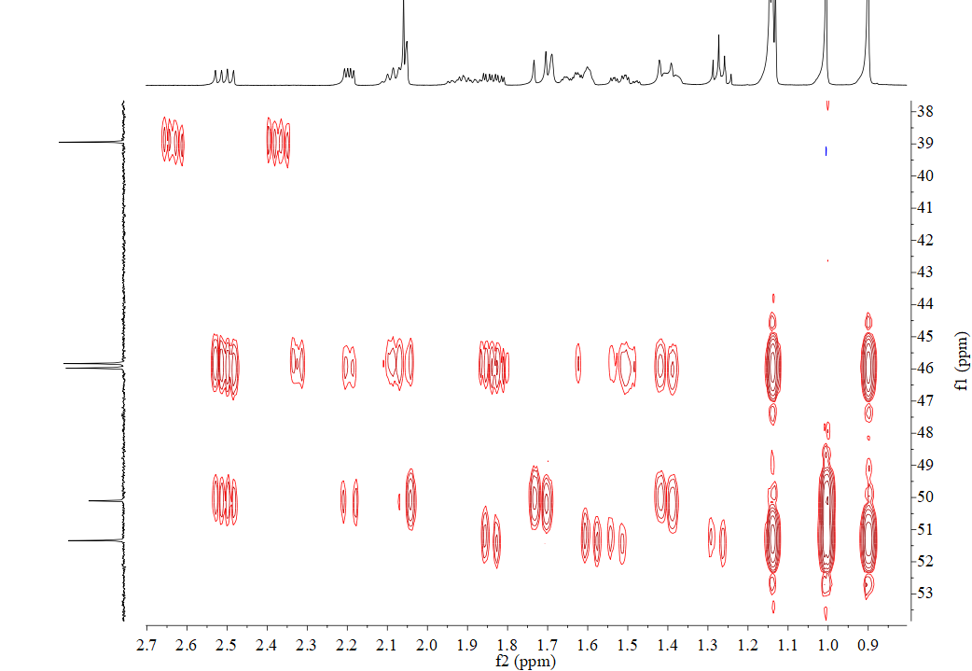
H14/C12
H6/C12
H15/C12
H12b/C5
H12a/C5
H8/C5
H2/C5
H3a/C5
H12b/C5
H6/C5
H14/C11
H15/C11
H9b/C11
H10b/C11
H10a/C11
H10b/C2
H10a/C2
H3b/C11
H3b/C2
H3a/C2
H3a/C11
H8/C2
H2/C11
Figure S9: HMBC Spectrum of 1 (isosuberosenol A) (From δ_{C} 38 ppm to δ_{C} 53 ppm )
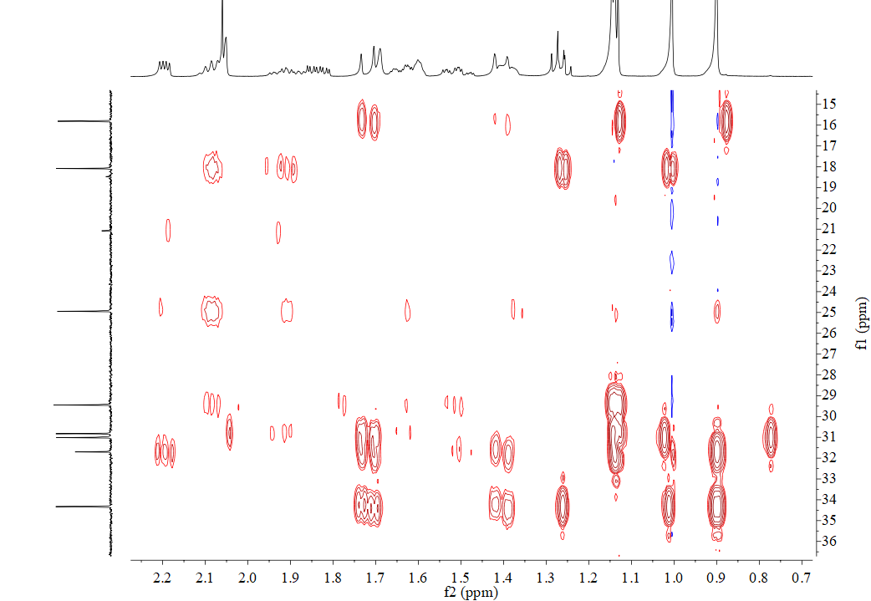
H14/C15
H12b/C15
H12a/C15
H14/C13
H15/C13
H12b/C13
H12a/C13
H2/C13
H15/C14
H7/C8
H12a/C14
H7/C9
H8/C9
H9a/C10
H8/C10
H9a/C7
H8/C7
H12a/C6
Figure S10: HMBC Spectrum of 1 (isosuberosenol A) (From δ_{C} 15 ppm to δ_{C} 36 ppm )
H12b/C6
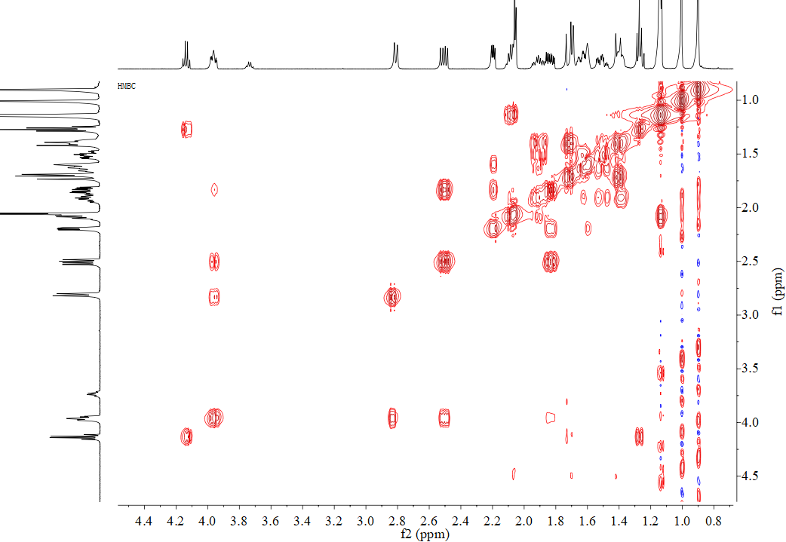
Figure S11: ¹H-¹H COSY Spectrum of 1 (isosuberosenol A)
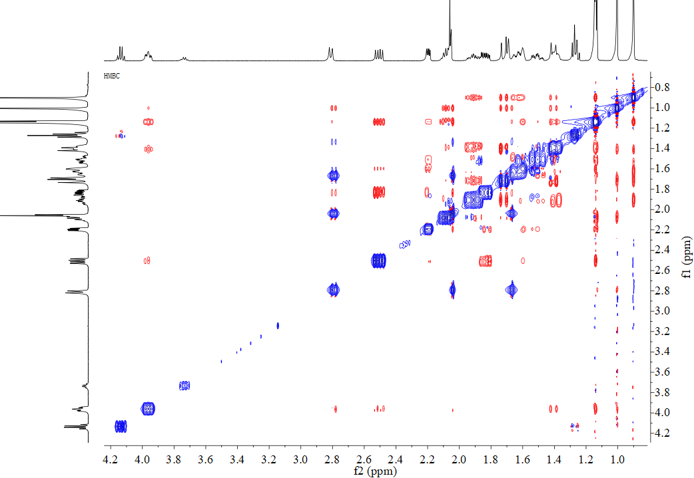
Figure S12: NOESY Spectrum of 1 (isosuberosenol A)
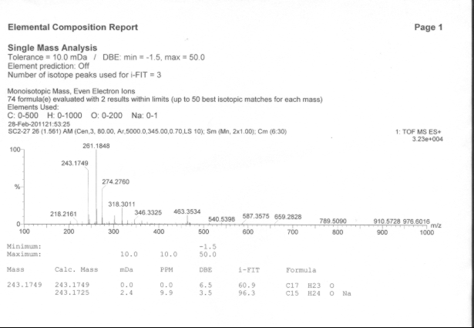
Figure S13: HR-ESI-MS Spectrum of 2 (suberosain A)
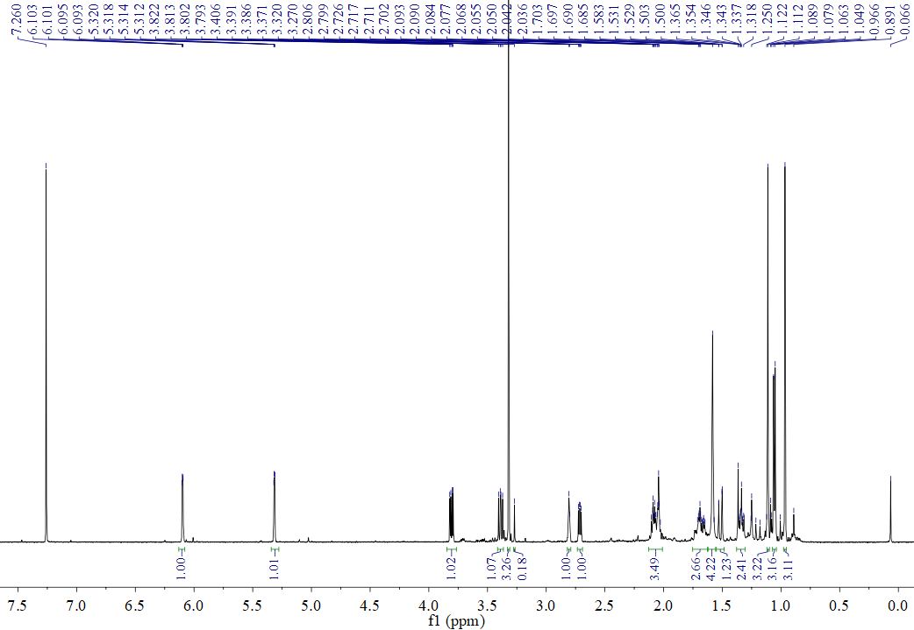
Figure S14: ¹H-NMR (500 MHz, CDCl₃) Spectrum of 2 (suberosain A)
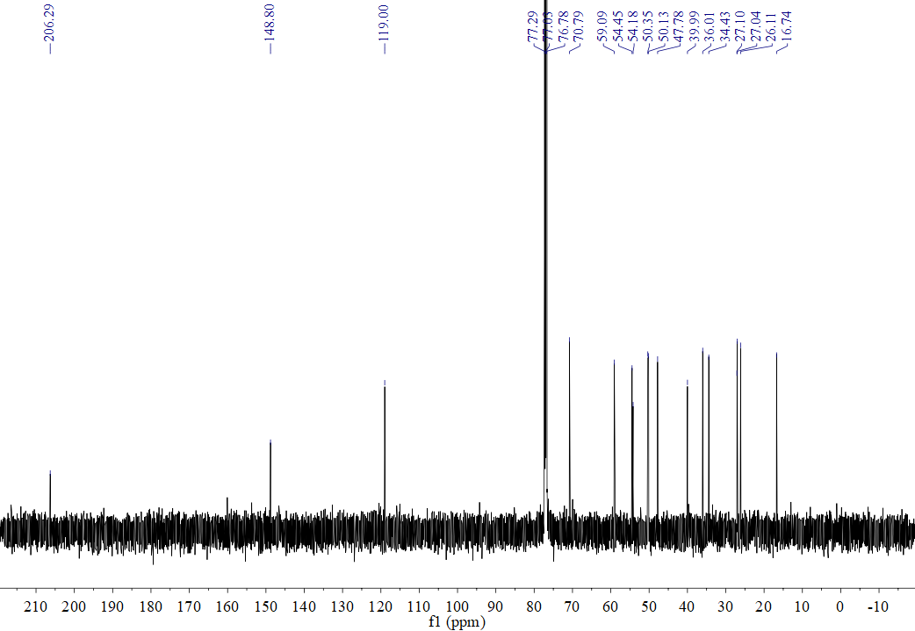
Figure S15: ¹³C-NMR (125 MHz, CDCl₃) Spectrum of 2 (suberosain A)
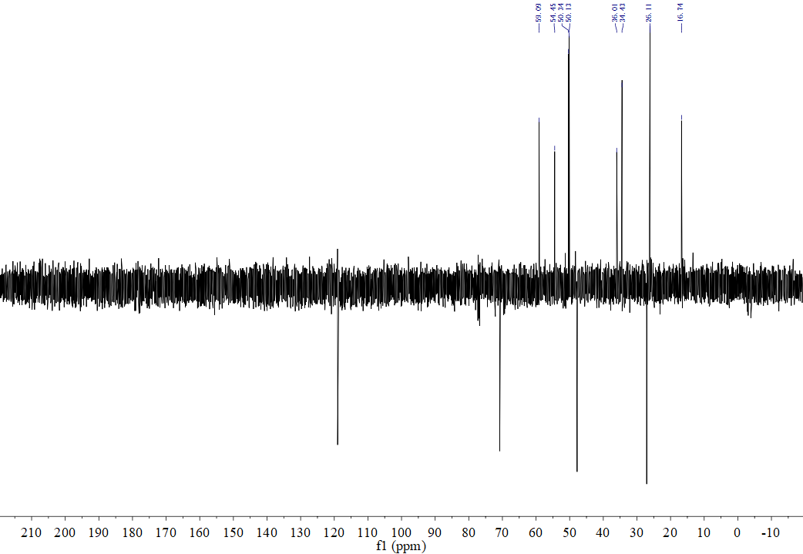
Figure S16: DEPT135 (125 MHz, CDCl₃) Spectrum of 2 (suberosain A)
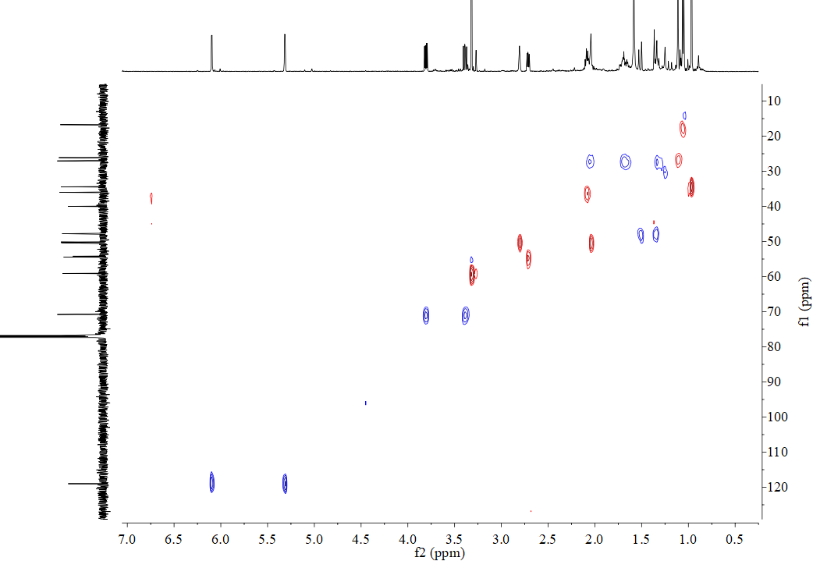
H16a/C16
H16b/C16
H6a/C6
H6b/C6
H-OMe/C-OMe
H5/C5
H11/C11
H2/C2
Figure S17: HSQC Spectrum of 2 (suberosain A)
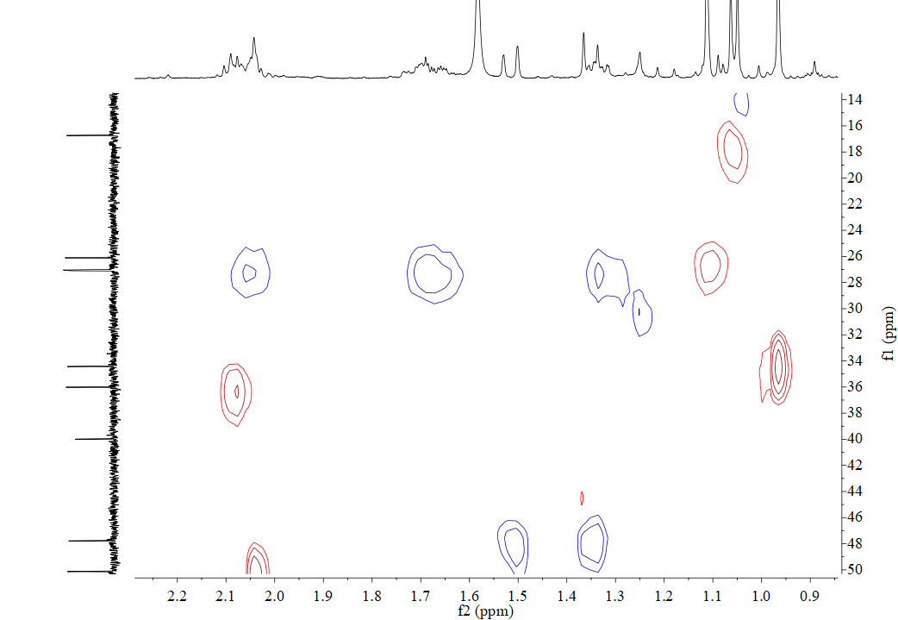
H12a/C12
H12/C12
H8/C8
H15/C15
H10/C10
H14/C14
H7/C7
Figure S18: HSQC Spectrum of 2 (suberosain A) (From δ_{C} 14 ppm to 50 ppm)
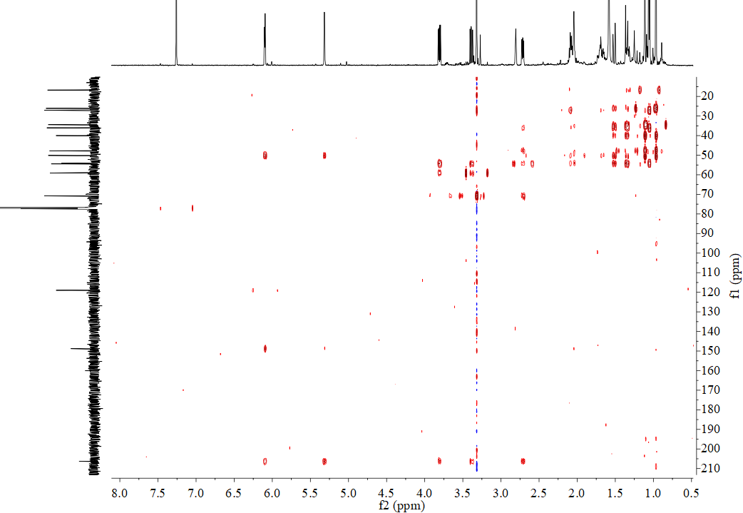
H16a/C4
H16b/C4
H6a/C4
H6b/C4
H5/C4
H16a/C3
H16a/C2
H16b/C2
Figure S19: HMBC Spectrum of 2 (suberosain A)
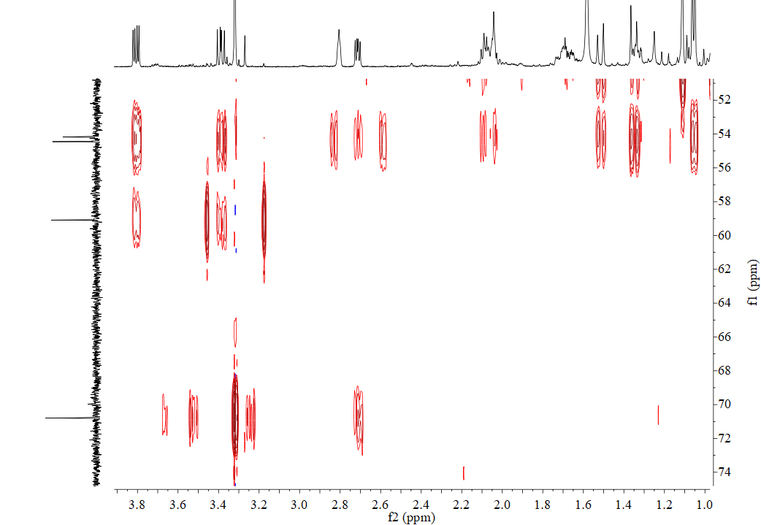
H5/C6
H-OMe/C6
H6a/C-OMe
H6b/C-OMe
H6a/C5
H6a/C1
H6b/C5
H6b/C1
H8/C1
H9a/C1
H11/C1
H8/C5
H12a/C5
H12a/C1
H12b/C5
H12b/C1
H7/C1
Figure S20: HMBC Spectrum of 2 (suberosain A) (From δ_{C} 52 ppm to 75 ppm)
H5/C1
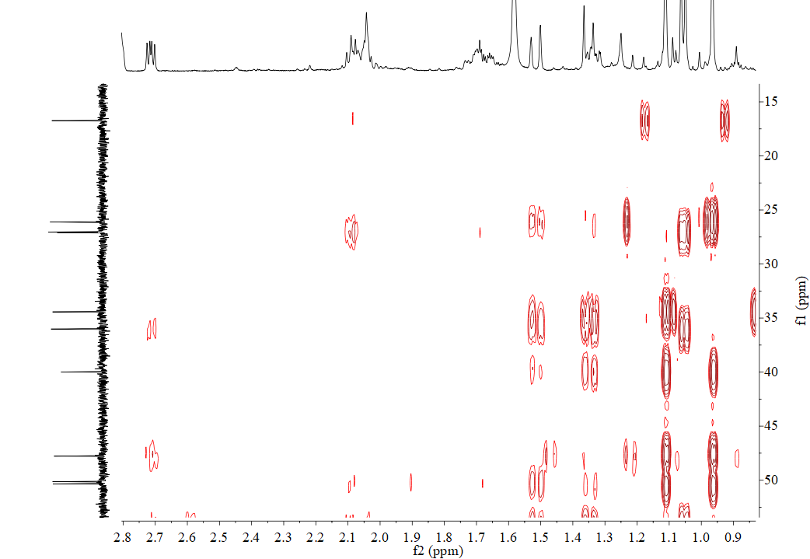
H14/C11
H12a/C2
H12b/C2
H15/C11
H14/C12
H15/C12
H5/C12
H14/C13
H15/C13
H12a/C13
H12b/C13
H12a/C8
H12b/C8
H7/C8
H5/C8
H12a/C14
H12b/C15
H14/C15
H7/C9
H15/C14
H12b/C14
H12a/C15
H8/C9
H8/C10
H9a/C10
H8/C7
Figure S21: HMBC Spectrum of 2 (suberosain A) (From δ_{C} 15 ppm to 50 ppm)
H11/C10
H11/C9
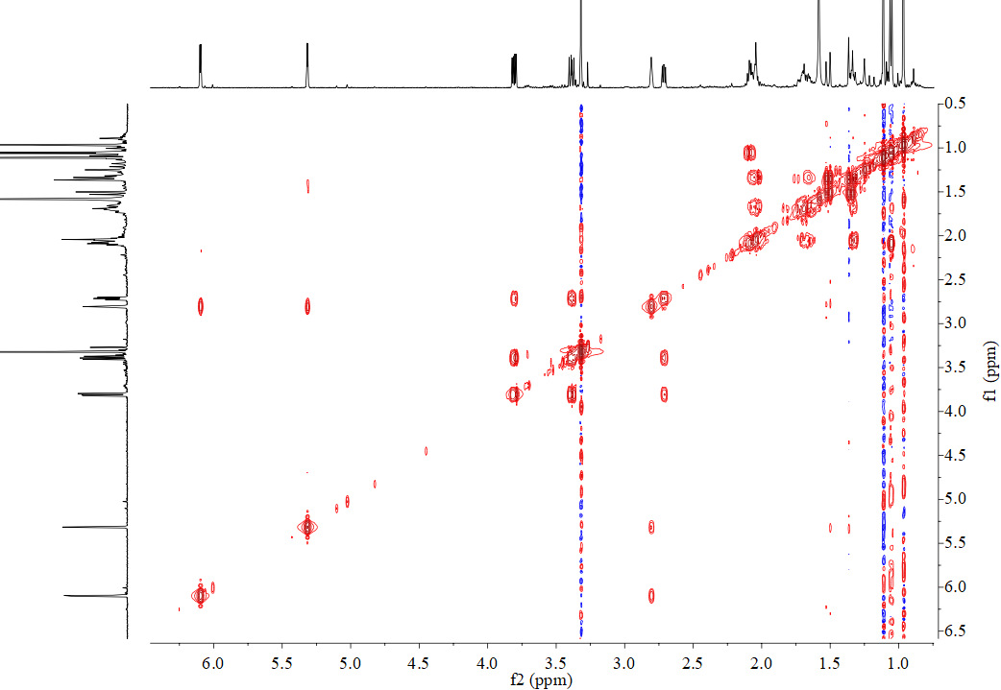
Figure S22: ¹H-¹H COSY Spectrum of 2 (suberosain A)
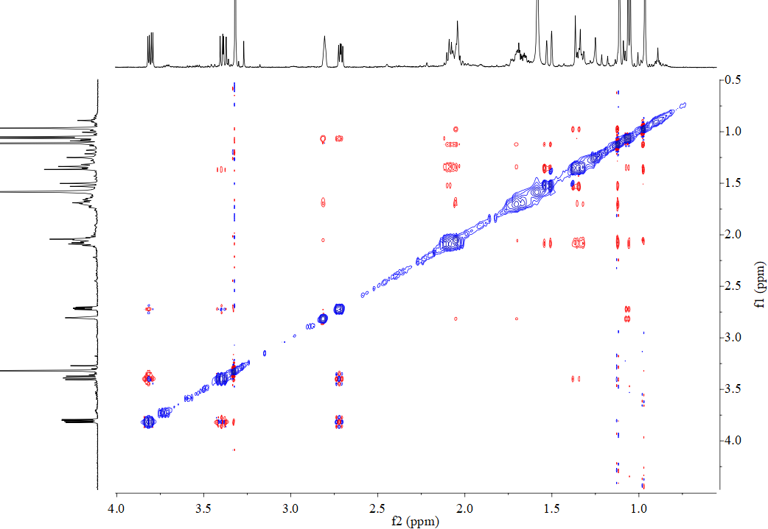
Figure S23: NOESY Spectrum of 2 (suberosain A)
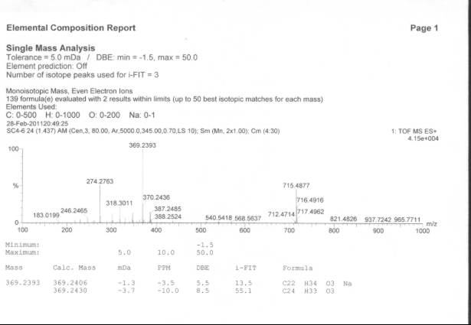
Figure S24: HR-ESI-MS Spectrum of 3 (4-hydroxymethyl-5β-pregnan-3, 20-dione)
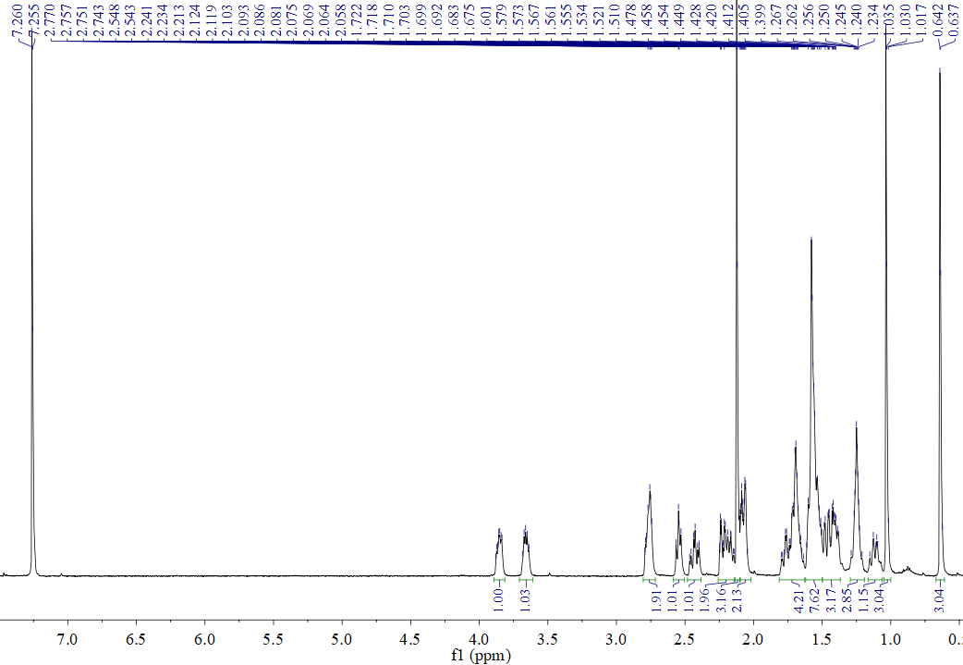
Figure S25: ¹H-NMR (500 MHz, CDCl₃) Spectrum of 3 (4-hydroxymethyl-5β-pregnan-3, 20-dione)
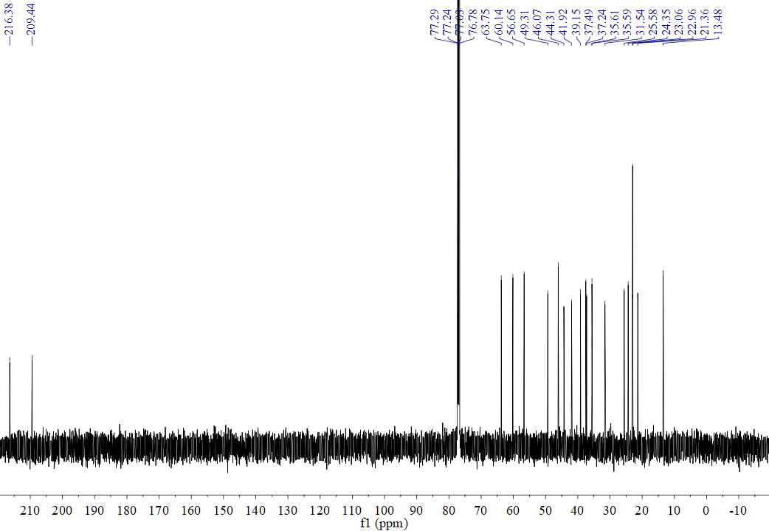
Figure S26: ¹³C-NMR (125 MHz, CDCl₃) Spectrum of 3 (4-hydroxymethyl-5β-pregnan-3, 20-dione)
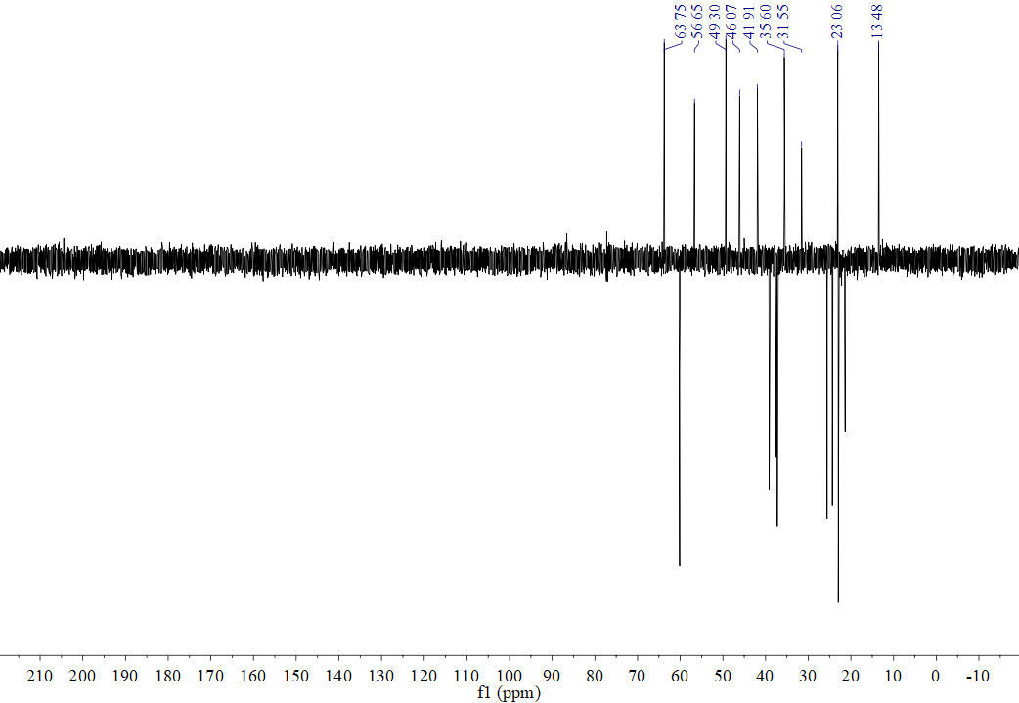
Figure S27: DEPT135 (125 MHz, CDCl₃) Spectrum of 3 (4-hydroxymethyl-5β-pregnan-3, 20-dione)
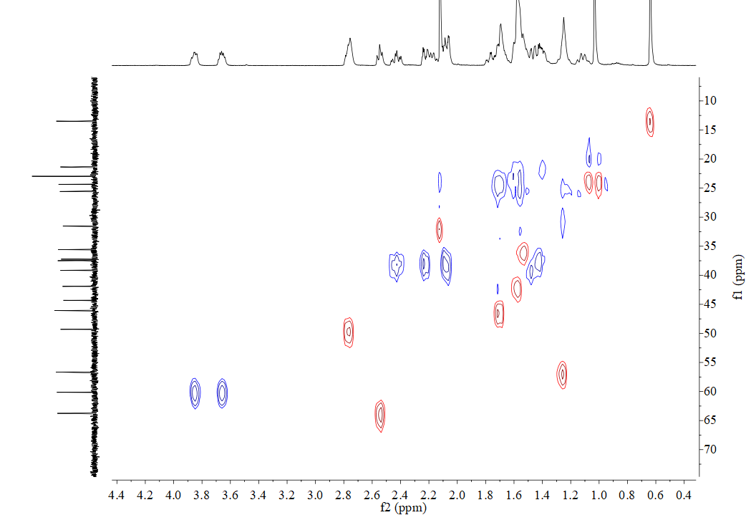
H17/C17
H22a/C22
H22b/C22
H14/C14
H4/C4
H5/C5
H9/C9
Figure S28: HSQC Spectrum of 3 (4-hydroxymethyl-5β-pregnan-3, 20-dione)
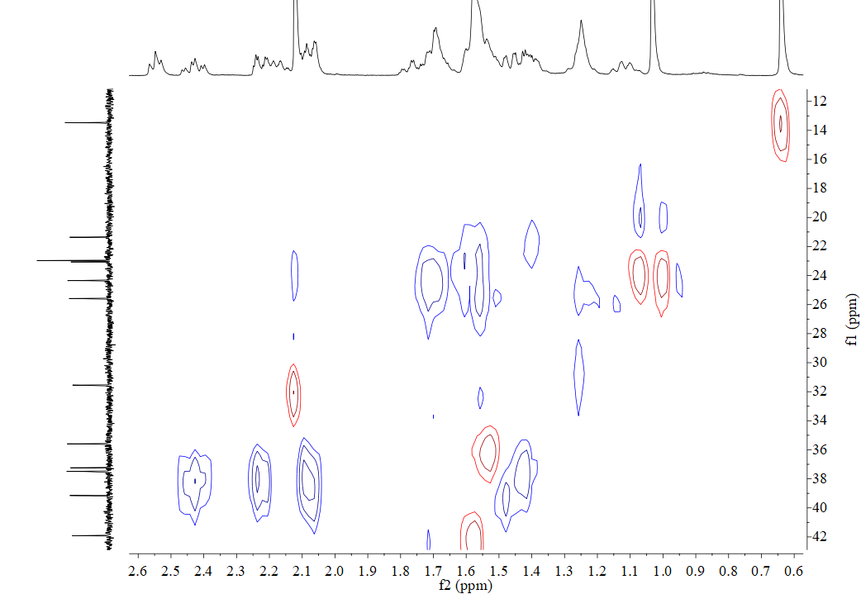
H12/C12
H2a/C2
H2b/C2
H1a/C1
H1a/C1
H8/C8
H11a/C11
H11b/C11
H6/C6
H19/C19
H16/C16
H15/C15
H7a/C7
H7b/C7
H18/C18
Figure S29: HSQC Spectrum of 3 (4-hydroxymethyl-5β-pregnan-3, 20-dione) (From δ_{C} 12 to 42)
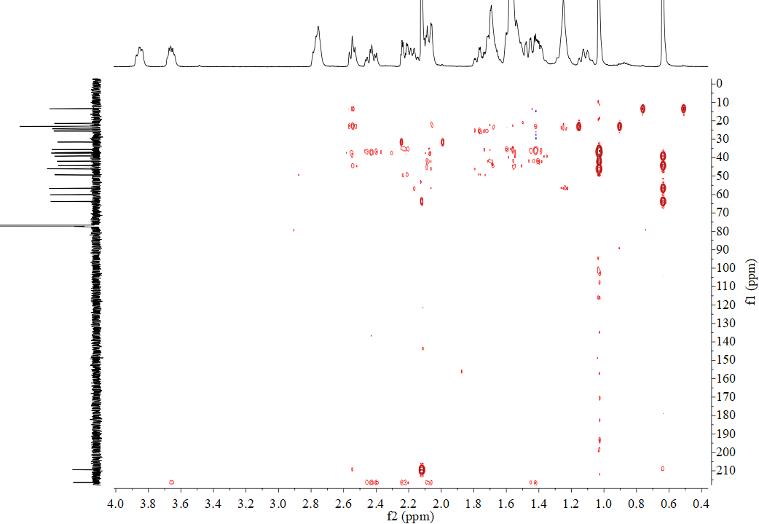
H1b/C3
H1a/C3
H2a/C3
H2b/C3
H21/C20
H17/C20
H22b/C3
Figure S30: HMBC Spectrum of 3 (4-hydroxymethyl-5β-pregnan-3, 20-dione)
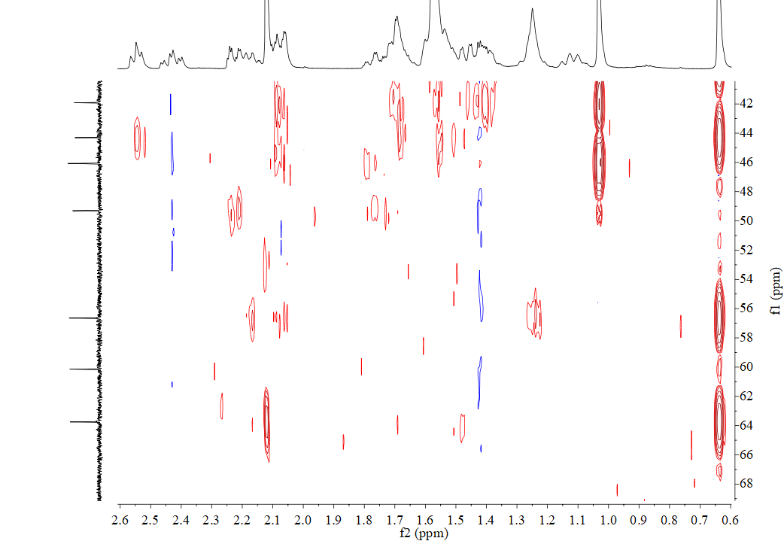
H18/C17
H12/C17
H16/C17
H21/C17
H18/C14
H2b/C4
H5/C4
H19/C5
H1a/C5
H18/C13
H8/C13
H16/C13
H19/C9
H7b/C9
H1b/C9
H12/C9
H5/C9
H11a/C9
H1a/C9
H17/C13
Figure S31: HMBC Spectrum of 3 (4-hydroxymethyl-5β-pregnan-3, 20-dione) (From δ_{C} 42 to 70)
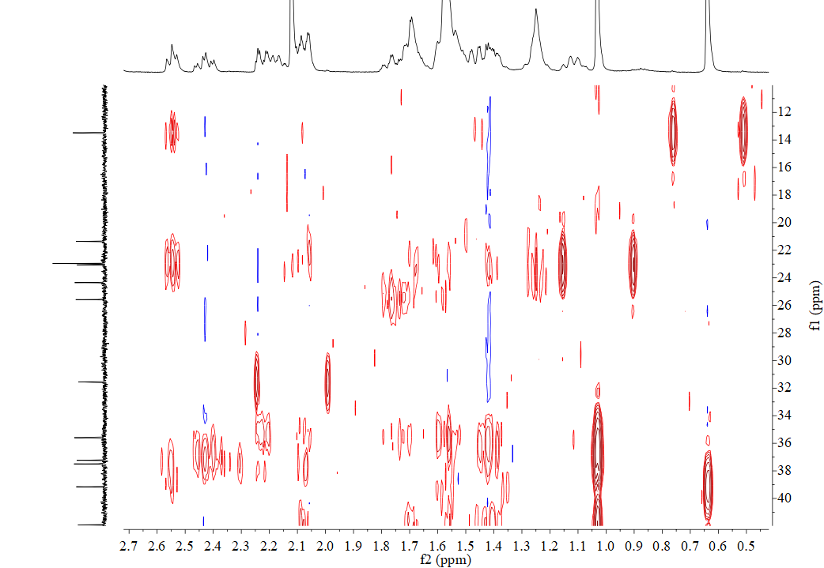
H18/C12
H17/C12
H19/C1
H19/C10
H1b/C2
H1a/C2
H2a/C1
H9/C1
H9/C11
H1b/C10
H9/C10
H2b/C10
H2a/C10
H5/C6
H1b/C19
H9/C19
H14/C15
H14/C16
H16/C15
H17/C16
H17/C15
H17/C18
H12/C18
Figure S32: HMBC Spectrum of 3 (4-hydroxymethyl-5β-pregnan-3, 20-dione) (From δ_{C} 12 to 40)
H5/C10
H1a/C10
H9/C8
H7b/C8
H7a/C8
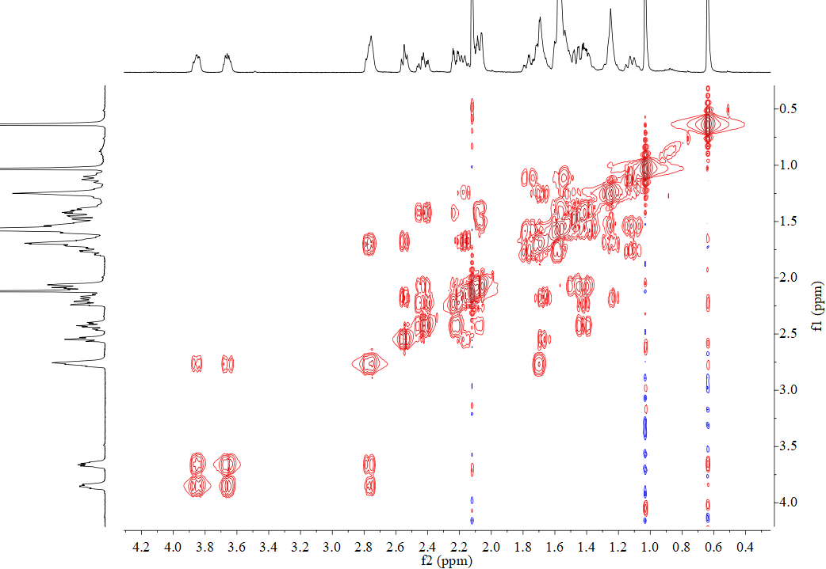
Figure S33: ¹H-¹H COSY Spectrum of 3 (4-hydroxymethyl-5β-pregnan-3, 20-dione)
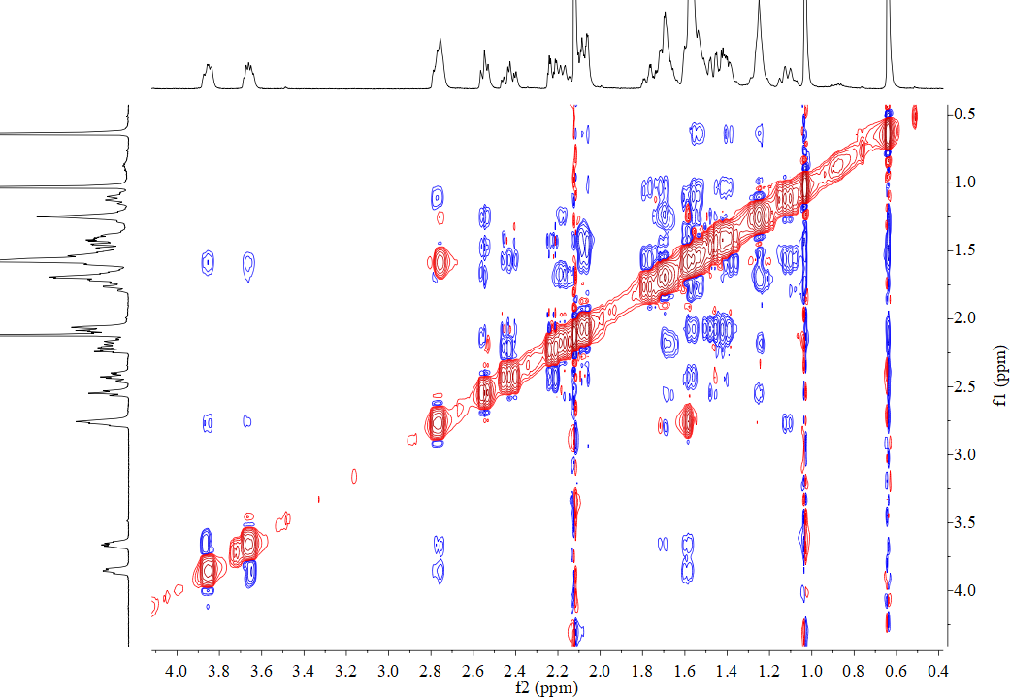
Figure S34: NOESY Spectrum of 3 (4-hydroxymethyl-5β-pregnan-3, 20-dione)

