Supporting Information
Rec. Nat. Prod. 14:4 (2020) 231-247
¹H NMR-Based Metabolomics of Clinacanthus nutans Leaves Extracts in Correlation with Their
Anti-neuroinflammation Towards LPS-Induced BV2 Cells
Amalina Ahmad Azam¹, Intan Safinar Ismail ¹*, Sharmili Vidyadaran², Faridah Abas¹ and Khozirah Shaari¹
¹Laboratory of Natural Products, Institute of Bioscience, Universiti Putra Malaysia, 43400 UPM Serdang, Selangor, Malaysia
² Department of Pathology, Faculty of Medicine and Health Sciences, Universiti Putra Malaysia, 43400 UPM Serdang, Selangor, Malaysia
Table of Contents | Page
Table S1 : List of putative compounds and their chemical shifts | 2
Figure S2: Different solvent polarities of CN extracts in (A) PCA scores plot, and (B) loading scatter plot | 3
Figure S3: Dose-response graph of percentage of LPS induce NO production (%) vs log (concentration) at 48 hours | 3

Table S1 : List of putative compounds and their chemical shifts
 | Metabolites | ¹H (ppm) and multiplicity (J=Hz)*
1 | Stigmasterol | 0.71 (s), 0.83 (m), 1.03 (s)
2 | Isoleucine | 0.9 (t), 1.1 (d), 1.25 (m)
3 | Valine | 1.06 (d, 7.0), 1.01 (d, 7.0)
4 | β-Sitosterol | 1.02 (s), 0.93 (d, 6.5)
5 | Butyrate | 0.94 (t), 1.55 (m), 2.14 (t, 7.3)
6 | Propionate | 1.04 (t, 7.6), 2.17 (q)
7 | Stigmasterol-β-D-glucoside | 1.22 (m)
8 | Alanine | 3.73 (q), 1.49 (d, 7.5)
9 | Leucine | 1.6 (m), 1.77 (m), 4.28 (d, 8.85)
10 | Citraconate | 1.9 (d), 5.7 (d)
11 | Acetate | 1.94 (s)
12 | Glutamate | 2.35 (m), 2.07 (m)
13 | Glutamine | 2.47 (m), 2.16 (m)
14 | Clinacoside B | 4.20 (m), 4.19 (m), 3.90 (m), 2.45 (s)
15 | Citric acid | 2.70 (d, 17.0), 2.53 (d, 17.0)
16 | Catechin | 4.59 (d, 8.0), 3.95 (m), 2.83 (m)
17 | Clinacoside A | 4.73 (d, 8.0), 4.11 (m), 4.10 (m), 2.94 (s)
18 | Orientin | 7.33 (d, 8.0), 7.22 (s), 6.58 (d, 8.0), 5.69 (s), 4.74 (d, 9.5), 3.92-3.28 (m)
19 | Gendarucin A | 8.21 (s), 6.99 (d, 8.5), 6.94 (s), 6.90 (d, 8.0), 3.00 (m), 4.88 (s), 3.75-3.70 (m), 3.62-3.58 (m)
20 | Choline | 3.24 (s)
21 | Schaftoside | 7.98 (d, 8.0), 6.90 (d, 8.5), 6.80 (s), 4.74 (d, 9.5), 3.26 (s)
22 | Mixture of cerebrosides | 7.64 (d, 9.0), 4.28 (d, 8.5), 4.28 (m), 3.94 (m), 3.60 (dd, 11.5, 3.5), 3.53 (m), 3.52 (m), 3.38 (t, 9.0), 2.07 (m), 1.56 (m), 1.25 (s)
23 | Sucrose | 3.5 (m), 5.43 (d, 3.5), 4.18 (d, 8.5)
24 | Fructose | 3.75 (m), 4.18 (d, 8.5)
25 | Vanilic acid (phenol) | 3.86 (s), 6.93 (d), 7.54 (d)
26 | Clinacoside C | 3.85 (m), 3.75 (m), 2.62 (s)
27 | Ascorbic acid | 4.53 (d, 8.0) ,3.72 (m)
28 | Betulin | 4.68 (s), 4.61 (s), 1.00 (s), 0.98 (s), 0.96 (s), 1.0 (s), 4.67 (d, 7.0), 4.59 (d, 7.0)
29 | Cycloclinacoside A1 | 4.73 (m), 4.72 (m), 4.67 (d, 7.5), 4.06 (m), 3.48 (m), 3.47 (s)
30 | α-Glucose | 5.19 (d, 3.5), 3.28 (dd)
31 | β-Glucose | 4.58 (d, 8.0)
32 | Quercetin 3-O-rhamnoside | 7.73 (d, 2.0), 6.89 (d, 8.5), 5.47 (d, 2.0), 0.91 (d, 6.0)
33 | cis-Aconitate | 5.95 (s)
34 | Isoorientin | 7.41 (s), 7.39 (d, 8.0), 6.90 (d, 7.5), 6.69 (s)
35 | Monoacylmonogalactosylglycerol | 4.23 (d, 7.5), 3.89 (m), 3.72 (dd, 10.5, 3.5), 3.51 (m), 1.34 (m), 1.30 (s)
36 | Gallic acid | 7.08 (s)
37 | Proline | 2.34 (m)
38 | Tryptophan | 7.72 (d, 8.0), 7.34 (s)
39 | Cycloclinacoside A2 | 4.67 (d, 8.0), 3.32 (s)
40 | Chlorogenic acid | 7.61 (d, 16.0), 1.91 (d, 10.0)
41 | Quercetin | 7.73 (d, 2.0), 6.85 (d, 8.0), 6.42 (s)
42 | Vitexin | 8.00 (d, 8.0), 6.91 (d, 8.5), 6.77 (s), 4.85-3.76 (m)
43 | Adenine | 8.21 (s), 8.19 (s)
44 | Formic acid | 8.47 (s)
s= singlet; d= doublet; dd= doublet of doublet; t= triplet; q=quartet; m= multiplet
*Any splitting pattern without coupling value is due to extreme overlapping of peaks, and the pattern has been suggested based on the result of J-Res

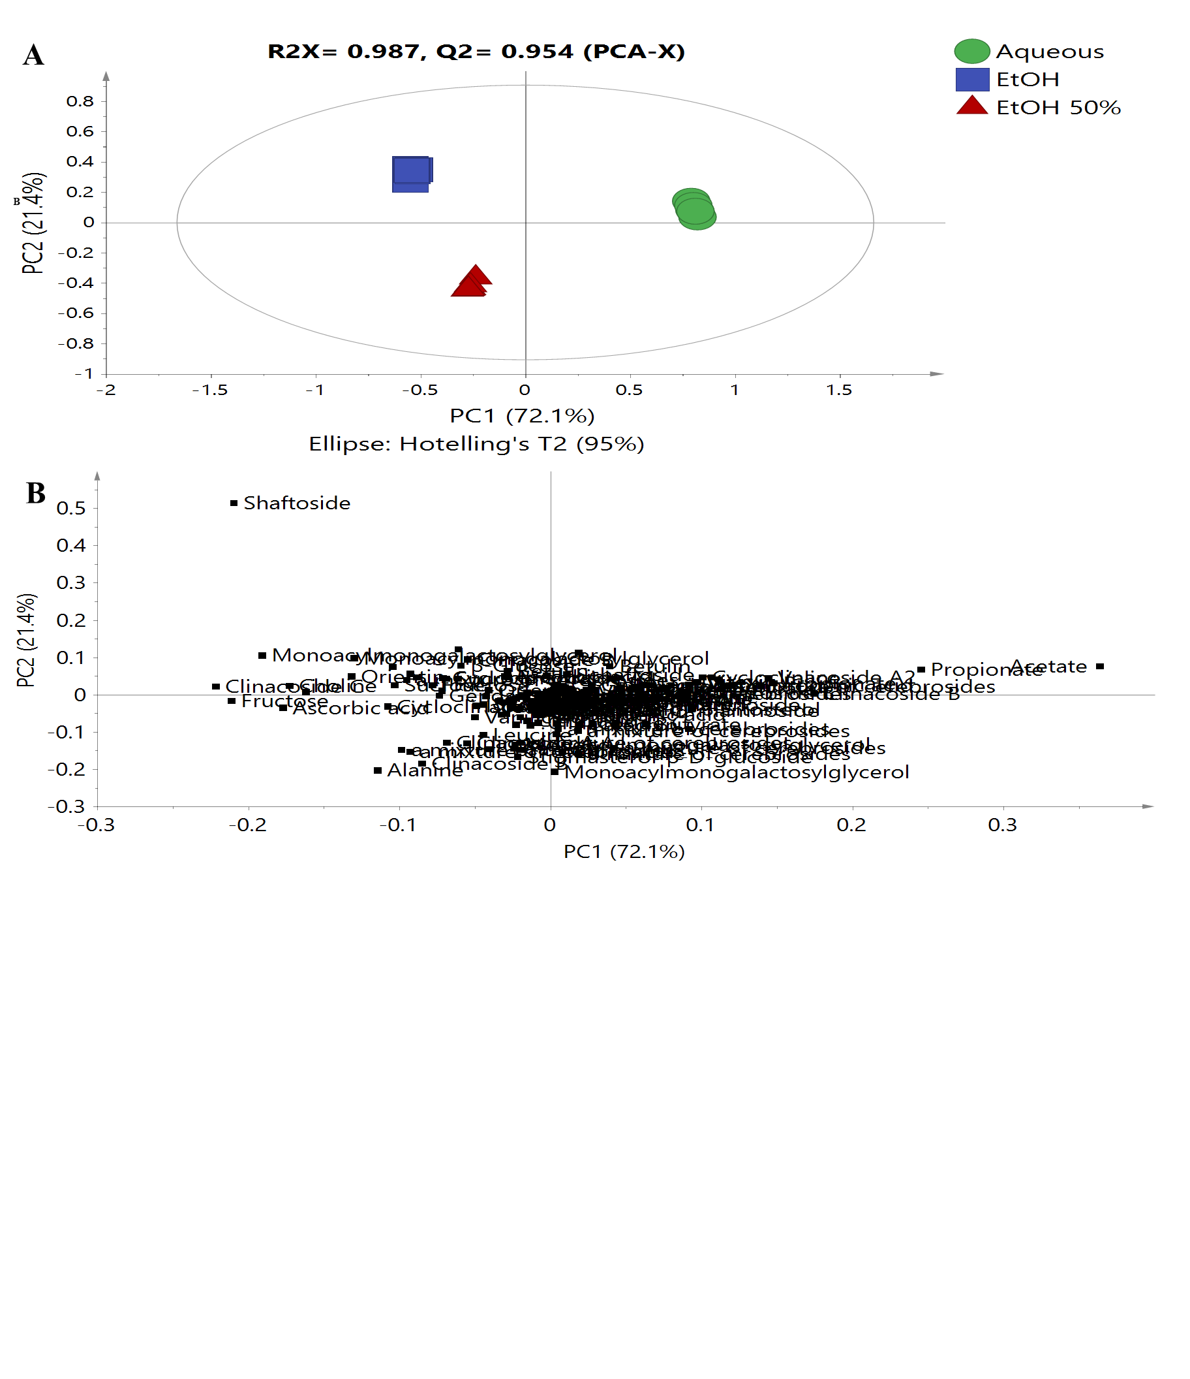
Figure S2: Different solvent polarities of CN extracts in (A) PCA scores plot, and (B) loading scatter plot
Figure S3: Dose-response graph of percentage of LPS induce NO production (%) vs log (concentration) at 48 hours

