Supporting Information
J. Chem. Metrol. 14:2 (2020) 177-189
A Year - round monitoring of ambient volatile organic compounds across dardanelles strait

Sibel Mentese ∗ and Batuhan Bas
Çanakkale Onsekiz Mart University, Faculty of Engineering, Environmental Engineering Department, Çanakkale, Türkiye

Table of Contents | Page
1. Repeatability, reproducibility, and stability of the air flow rate by low–flow air sampling pump used for active sampling | 2
2. Repeatability, reproducibility, and linearity of the individual VOC compound quantification | 2
Table S1: Repeatability and reproducibility of the lowest (S_{min}) and the highest concentration (S_{max}) and the linearity estimate (R²) | 3
3. Calibration results of VOCs | 4
Figure S1: Calibration curves of BTEX compounds | 4
4. Passive (Diffusive) VOC sampling | 5
Table S2: Concentrations (µg/m³) of the selected VOCs by passive/diffusive sampling campaign at the sampling points | 6

1. Repeatability, reproducibility, and stability of the air flow rate by low–flow air sampling pump used for active sampling

To eliminate uncertainty due to equipment, environment, and operator, all tests were done by the same operator with the same instruments at the same environment.

Repeatability of the air sampling pump’s flow readings = 0.51 mL/min (n: 20)

Reproducibility of the air sampling pump’s flow readings for 2 sets of calibration = 0.0055 mL/min (n: 20 for each set)

Stability of the 3 calibration results of the air sampling pump flow readings = 0.58 ml/min (n: 20 for each calibration set)

2. Repeatability, reproducibility, and linearity of the individual VOC compound quantification

To eliminate uncertainty due to equipment, environment, and operator, all analysis and calibration studies performed by TD and GC were done by the same operator with the same instruments at the same environment.

S_{min} (the lowest calibration standard concentration): 5 ng for single compound peak and 10 ng for total peak of two-compounds

S_{max} (the highest calibration standard concentration): 200 ng for single compound peak and 400 ng for total peak of two-compounds

Repeatability of the mass of analyte in the standard solutions used for VOC calibration at GC Instrument was calculated for each target VOC species (n: 7). Among 3 calibration studies conducted in different days, the one that had the best calibration curves was considered in the study.

Reproducibility of the mass of analyte in the standard solutions used for VOC calibration at GC Instrument was calculated for each target VOC species performed from 2 sets of calibration (n: 7 for each set)

In terms of linearity of the calibration curves, R² was calculated for the average peak area obtained from 7-replicates of each standard concentration of target VOC species in the standard solutions.

Table S1: Repeatability and reproducibility of the lowest (S_{min}) and the highest concentration (S_{max}) and the linearity estimate (R²)
Compound | Smin |  | Smax |  | R²
Compound | Repeatability (ng) | Reproducibility (ng) | Repeatability (ng) | Reproducibility (ng) | R²
benzene | 0.12 | 0.001 | 4.2 | 0.141 | 0.9958
toluene | 0.10 | 0.028 | 3.9 | 0.273 | 0.9958
ethylbenzene | 0.11 | 0.021 | 4.0 | 0.778 | 0.9943
m,p-xylene | 0.20 | 0.085 | 6.9 | 0.758 | 0.9941
o-xylene | 0.12 | 0.028 | 3.9 | 0.636 | 0.9962
styrene | 0.11 | 0.021 | 3.8 | 0.495 | 0.9960
isopropylbenzene | 0.13 | 0.028 | 4.1 | 0.636 | 0.9975
n-propylbenzene | 0.14 | 0.035 | 4.2 | 0.707 | 0.9972
1,3,5-trimethylbenzene | 0.09 | 0.009 | 4.0 | 0.566 | 0.9986
tertiary-butylbenzene | 0.08 | 0.007 | 3.9 | 0.424 | 0.9947
1,2,4-trimethylbenzene | 0.09 | 0.007 | 3.8 | 0.354 | 0.9947
4-isopropyltoluene | 0.10 | 0.002 | 3.0 | 0.283 | 0.9983
n-butylbenzene | 0.15 | 0.035 | 4.5 | 0.778 | 0.9958
naphthalene | 0.09 | 0.007 | 2.1 | 0.919 | 0.9992
sec-butylbenzene+1,3-dichlorobenzene | 0.18 | 0.057 | 6.2 | 0.909 | 0.9957
bromobenzene | 0.11 | 0.007 | 3.2 | 0.212 | 0.9948
2-chlorotoluene | 0.10 | 0.003 | 3.5 | 0.354 | 0.9933
4-chlorotoluene | 0.11 | 0.007 | 3.4 | 0.141 | 0.9936
1,4-dichlorobenzene | 0.12 | 0.007 | 3.6 | 0.071 | 0.9974
1,2-dichlorobenzene | 0.12 | 0.007 | 3.8 | 0.283 | 0.9990
1,2,4-trichlorobenzene | 0.10 | 0.007 | 3.7 | 0.071 | 0.9966
hexa-chloro-1,3-butadiene | 0.19 | 0.057 | 4.2 | 0.283 | 0.9935
1,2,3-trichlorobenzene | 0.12 | 0.007 | 3.9 | 0.212 | 0.9979
n-pentane | 0.15 | 0.021 | 4.2 | 0.212 | 0.9924
n-hexane | 0.06 | 0.042 | 3.2 | 0.495 | 0.9985
n-heptane | 0.08 | 0.028 | 3.5 | 0.283 | 0.9998
n-octane | 0.08 | 0.028 | 3.4 | 0.424 | 0.9992
n-nonane | 0.09 | 0.021 | 3.5 | 0.354 | 0.9999
n-decane | 0.08 | 0.035 | 3.3 | 0.566 | 0.9999
n-undecane | 0.10 | 0.028 | 2.9 | 0.919 | 0.9994
n-dodecane | 0.11 | 0.028 | 3.0 | 0.849 | 0.9984
n-tridecane | 0.10 | 0.035 | 3.1 | 0.778 | 0.9999
n-tetradecane | 0.10 | 0.057 | 3.2 | 0.919 | 0.9990
n-pentadecane | 0.12 | 0.050 | 3.4 | 0.980 | 0.9999
n-hexadecane | 0.10 | 0.071 | 3.3 | 0.546 | 0.9991
3. Calibration Results of VOCs
Mass of compound (y) calculated for area (x) of each target VOCs calculated from 7-points calibration standards are shown in the scatter plots as y = slope.(x) linear equation and correlation coefficient (R²). As an example, calibration curves of BTEX are shown in Figure S1.

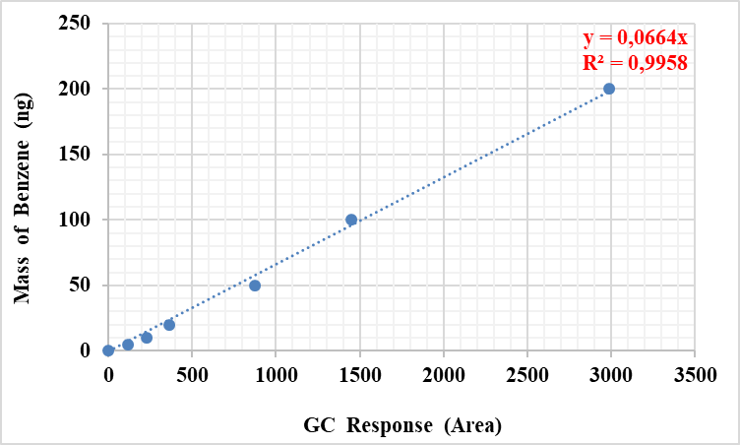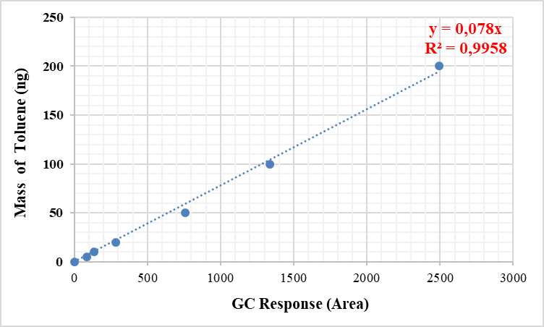

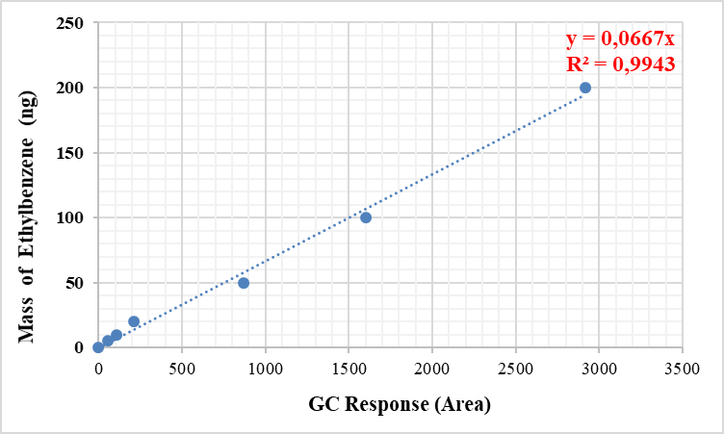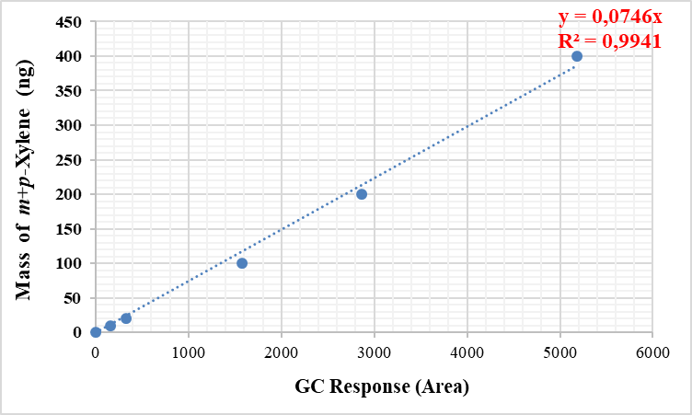

Figure S1: Calibration curves of BTEX compounds
4. Passive (Diffusive) VOC sampling

Mass concentration (µg/m³) of the analyte in the sampled air was calculated according to Fick’s First Law of diffusion, by Equation (1):

Eq.1

C =is the mass concentration of the analyte in the air sampled, µg/m³
Ma = is the mass of analyte present in the actual sample, µg
Mb = is the mass of analyte present in the blank tube, µg
q = is the diffusive uptake rate, m³/min (provided from ISO 16017-2 for the selected VOCs collected on sorbents used in this study)
t = is the exposure time, min
Table S2: Concentrations (µg/m³) of the selected VOCs by passive /diffusive sampling campaign at the sampling points.
Season | Concentration/Sampling point
Season | VOC specie | 1 | 2 | 3 | 4 | 5 | 6 | 7 | 8 | 9 | 10 | 11 | 12
Winter | Benzene | NA | NA | NA | <MDL | <MDL | NA | <MDL | NA | NA | <MDL | 0.2 | <MDL
 | Toluene | NA | NA | NA | 0.8 | <MDL | NA | <MDL | NA | NA | 0.1 | <MDL | 0.1
 | ethylbenzene | NA | NA | NA | <MDL | <MDL | NA | <MDL | NA | NA | <MDL | <MDL | <MDL
 | m,p-xylene | NA | NA | NA | <MDL | <MDL | NA | <MDL | NA | NA | <MDL | 0.1 | <MDL
 | o-xylene | NA | NA | NA | <MDL | <MDL | NA | <MDL | NA | NA | <MDL | <MDL | <MDL
 | TVOC | NA | NA | NA | 113.0 | 99.8 | NA | 152.7 | NA | NA | 106.3 | 19.2 | 31.0
Spring | Benzene | 0.7 | 0.1 | 0.1 | 0.5 | 0.7 | 0.7 | 0.1 | 0.9 | 0.7 | 1.0 | 0.6 | <MDL
 | Toluene | 0.7 | <MDL | <MDL | 0.4 | 0.7 | 0.7 | <MDL | 3.2 | 2.6 | 2.1 | 0.9 | <MDL
 | ethylbenzene | 0.2 | <MDL | <MDL | 0.1 | 0.3 | 0.1 | <MDL | 0.9 | 0.2 | 0.3 | 0.2 | <MDL
 | m,p-xylene | 0.9 | 0.1 | 0.1 | 0.3 | 0.8 | 0.5 | 0.1 | 2.5 | 1.2 | 1.4 | 0.7 | <MDL
 | o-xylene | 0.6 | 0.1 | 0.1 | 0.3 | 0.2 | 0.1 | 0.1 | 0.8 | 0.4 | 0.4 | 0.2 | <MDL
 | TVOC | 102.2 | 24.2 | 15.9 | 39.8 | 41.8 | 31.2 | 23.3 | 157.8 | 70.5 | 86.2 | 112.5 | 94.1
Summer | Benzene | 0.9 | 1.3 | 0.9 | 0.9 | 0.2 | 0.9 | 1.1 | 1.2 | 1.2 | 1.6 | 0.6 | 0.7
 | Toluene | 5.3 | 2.6 | 3.1 | 2.5 | 1.4 | 2.7 | 5.5 | 3.9 | 4.3 | 3.2 | 2.0 | 3.0
 | ethylbenzene | 0.6 | 0.4 | 0.4 | 0.2 | 0.1 | 0.3 | 0.8 | 0.5 | 0.9 | 0.5 | 11.4 | 0.5
 | m,p-xylene | 1.5 | 1.2 | 1.2 | 1.0 | 0.2 | 1.0 | 2.2 | 2.1 | 3.0 | 1.4 | 0.7 | 1.4
 | o-xylene | 0.2 | 0.4 | 0.4 | 0.3 | 0.4 | 0.2 | 0.3 | 0.4 | 0.3 | 0.3 | 0.2 | 0.2
 | TVOC | 105.7 | 112.0 | 85.3 | 76.0 | 50.7 | 66.2 | 78.4 | 120.1 | 127.1 | 111.0 | 268.5 | 137.1
Note that passive samples collected in fall season were not presented due to sample lost; NA: Not available, MDL: method detection limit; TVOC: total volatile organic compounds; Sampling points: 1-Yapıldak, 2-Lapseki, 3-Hamzakoy, 4-Ilgardere, 5-Eceabat, 6-Kilitbahir, 7-Soganlıdere, 8-Kordon, 9-Çimenlik citadel, 10-Kepez Harbor, 11-Dardanos, 12-Güzelyalı.

