Supporting Information
Org. Commun. X:X (202X) XX-XX
One-pot three-component synthesis and electrochemical béhavior studies of tetrahydrobenzo[b]pyrans using WEWFPA under microwave irradiation: Green protocol
Krishnappa B Badiger¹, Lokesh Koodlur Sannegowda²,
and Kantharaju Kamanna¹
Peptide and Medicinal Chemistry Research Laboratory, Department of Chemistry, Rani Channamma University, P-B, NH-4, Belagavi 591 156, India
²Department of Studies in Chemistry, Vijayanagara Sri Krishnadevaraya University, Ballari, Karnataka 583105, India
Table of Contents | Page
Figure S1: Biological applications of tetrahydrobenzo[b]pyran scaffolds | 3
Figure S2: FT-IR spectrum of ethyl-2-amino-4-(furan-2-yl)-7,7-dimethyl-5-oxo-5,6,7,8-tetrahydro-4H-chromene-3-carboxylate (4k) | 4
Figure S3: ¹H-NMR (DMSO) spectrum of ethyl-2-amino-4-(furan-2-yl)-7,7-dimethyl-5-oxo-5,6,7,8-tetrahydro-4H-chromene-3-carboxylate (4k) | 5
Figure S4: ¹³C-NMR (DMSO) spectrum of ethyl-2-amino-4-(furan-2-yl)-7,7-dimethyl-5-oxo-5,6,7,8-tetrahydro-4H-chromene-3-carboxylate (4k) | 5
Figure S5: LC profile of ethyl-2-amino-4-(furan-2-yl)-7,7-dimethyl-5-oxo-5,6,7,8-tetrahydro-4H-chromene-3-carboxylate (4k) | 6
Figure S6: LC-MS spectrum of ethyl-2-amino-4-(furan-2-yl)-7,7-dimethyl-5-oxo-5,6,7,8-tetrahydro-4H-chromene-3-carboxylate (4k) | 7
Figure S7: FT-IR spectrum of ethyl-2-amino-4-(6-methoxynaphthalen-2-yl)-7,7-dimethyl-5-oxo-5,6,7,8-tetrahydro-4H-chromene-3-carboxylate (4q) | 8
Figure S8: ¹H-NMR (DMSO) spectrum of ethyl-2-amino-4-(6-methoxynaphthalen-2-yl)-7,7-dimethyl-5-oxo-5,6,7,8-tetrahydro-4H-chromene-3-carboxylate (4q) | 8
Figure S9: ¹³C-NMR (DMSO) spectrum of ethyl-2-amino-4-(6-methoxynaphthalen-2-yl)-7,7-dimethyl-5-oxo-5,6,7,8-tetrahydro-4H-chromene-3-carboxylate (4q) | 9
Figure S10: LC profile of ethyl-2-amino-4-(6-methoxynaphthalen-2-yl)-7,7-dimethyl-5-oxo-5,6,7,8-tetrahydro-4H-chromene-3-carboxylate (4q) | 9
Figure S11: LC-MS spectrum of ethyl-2-amino-4-(6-methoxynaphthalen-2-yl)-7,7-dimethyl-5-oxo-5,6,7,8-tetrahydro-4H-chromene-3-carboxylate (4q) | 10
Figure S12: FT-IR spectrum of ethyl-2-amino-4-(6-chloropyridin-3-yl)-7,7-dimethyl-5-oxo-5,6,7,8-tetrahydro-4H-chromene-3-carboxylate (4r) | 11
Figure S13: ¹H-NMR (DMSO) spectrum of ethyl-2-amino-4-(6-chloropyridin-3-yl)-7,7-dimethyl-5-oxo-5,6,7,8-tetrahydro-4H-chromene-3-carboxylate (4r) | 11
Figure S14: ¹³C-NMR (DMSO) spectrum of ethyl-2-amino-4-(6-chloropyridin-3-yl)-7,7-dimethyl-5-oxo-5,6,7,8-tetrahydro-4H-chromene-3-carboxylate (4r) | 12
Figure S15: LC profile of ethyl-2-amino-4-(6-chloropyridin-3-yl)-7,7-dimethyl-5-oxo-5,6,7,8-tetrahydro-4H-chromene-3-carboxylate (4r) | 12
Figure S16: LC-MS spectrum of ethyl-2-amino-4-(6-chloropyridin-3-yl)-7,7-dimethyl-5-oxo-5,6,7,8-tetrahydro-4H-chromene-3-carboxylate (4r) | 13

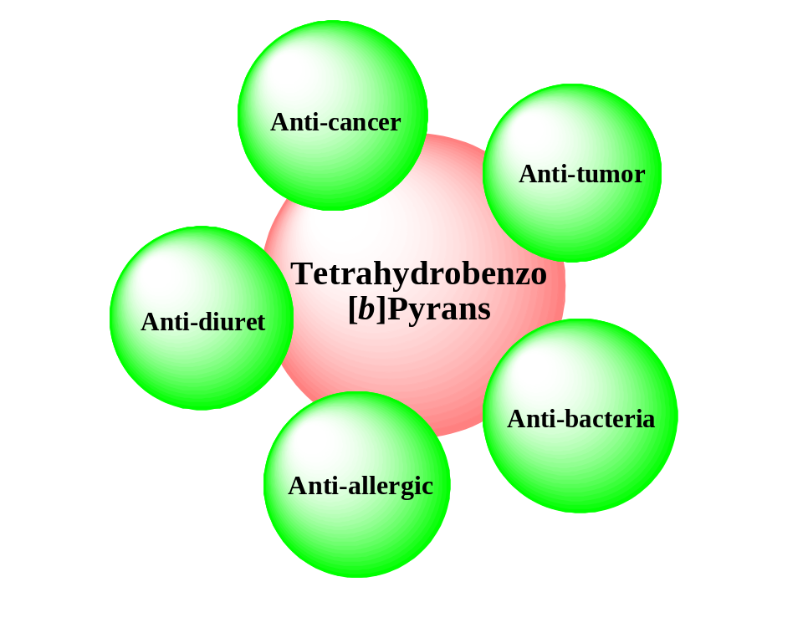
Figure S1: Biological applications of tetrahydrobenzo[b]pyran scaffolds

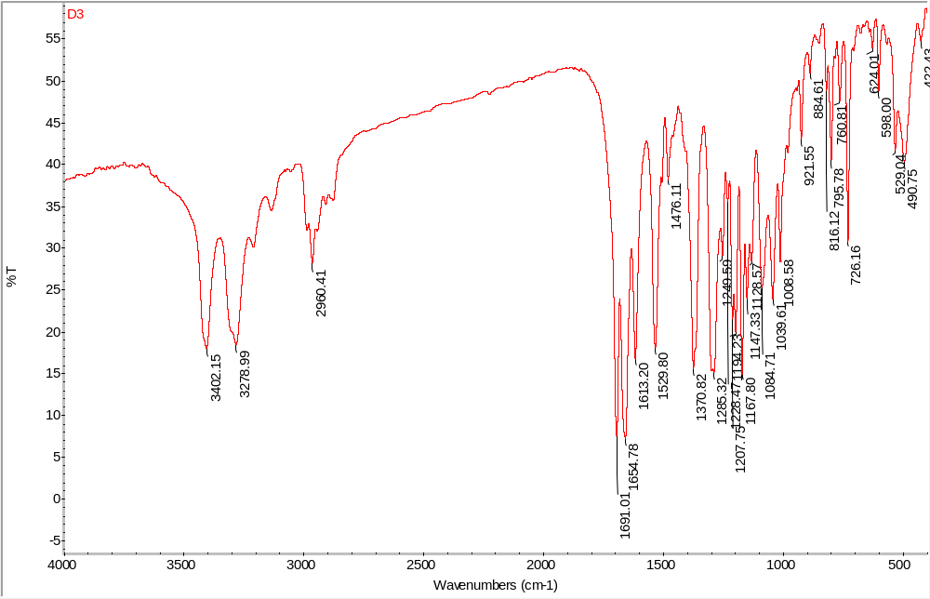
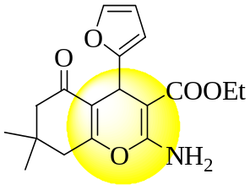

Figure S2: FT-IR spectrum of ethyl-2-amino-4-(furan-2-yl)-7,7-dimethyl-5-oxo-5,6,7,8-tetrahydro-4H-chromene-3-carboxylate (4k)
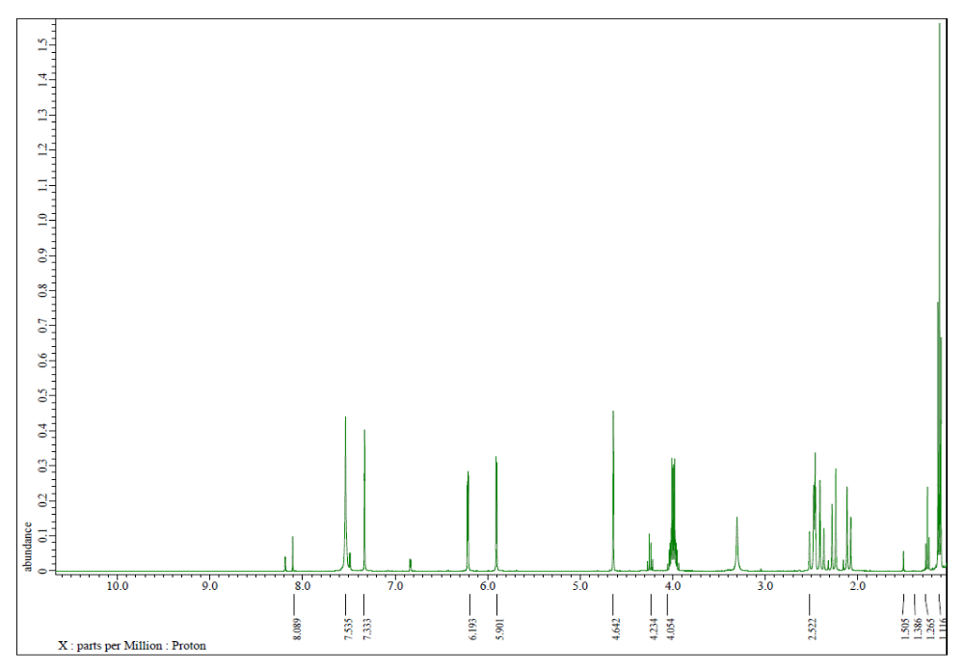
Figure S3: ¹H-NMR (DMSO) spectrum of ethyl-2-amino-4-(furan-2-yl)-7,7-dimethyl-5-oxo-5,6,7,8-tetrahydro-4H-chromene-3-carboxylate (4k)
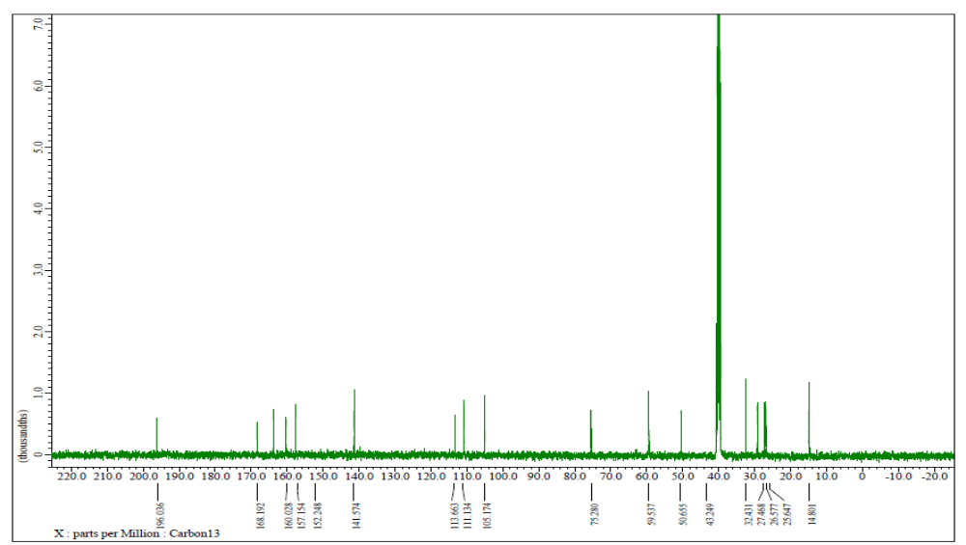
Figure S4: ¹³C-NMR (DMSO) spectrum of ethyl-2-amino-4-(furan-2-yl)-7,7-dimethyl-5-oxo-5,6,7,8-tetrahydro-4H-chromene-3-carboxylate (4k)
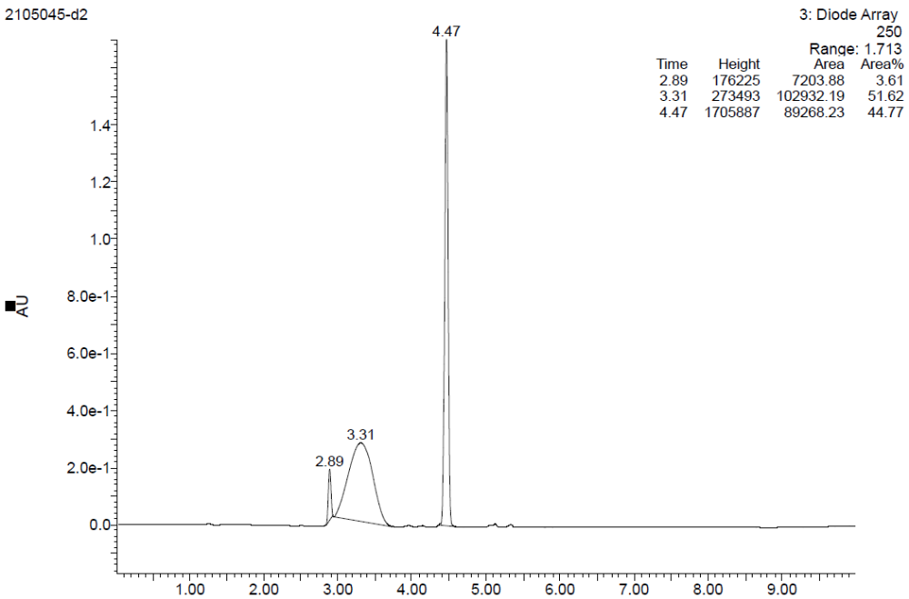
Figure S5: LC profile of spectrum of ethyl-2-amino-4-(furan-2-yl)-7,7-dimethyl-5-oxo-5,6,7,8-tetrahydro-4H-chromene-3-carboxylate (4k)

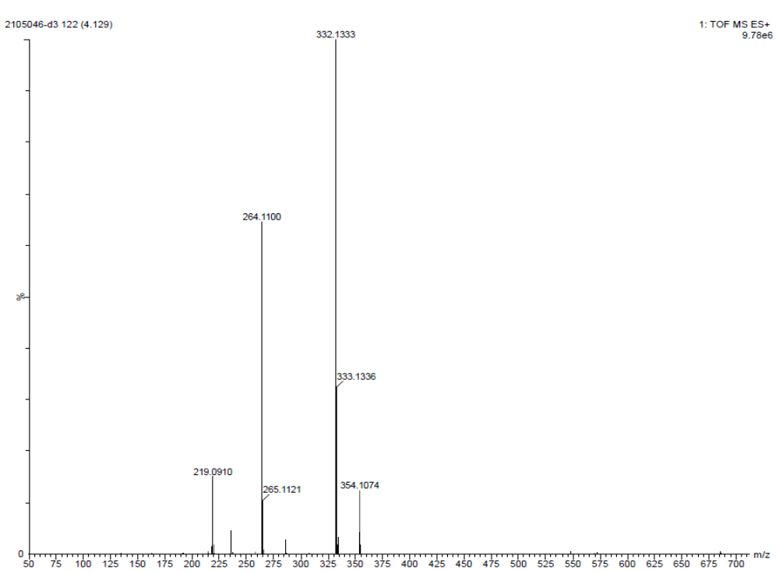
Figure S6: LC-MS spectrum of ethyl-2-amino-4-(furan-2-yl)-7,7-dimethyl-5-oxo-5,6,7,8-tetrahydro-4H-chromene-3-carboxylate (4k)

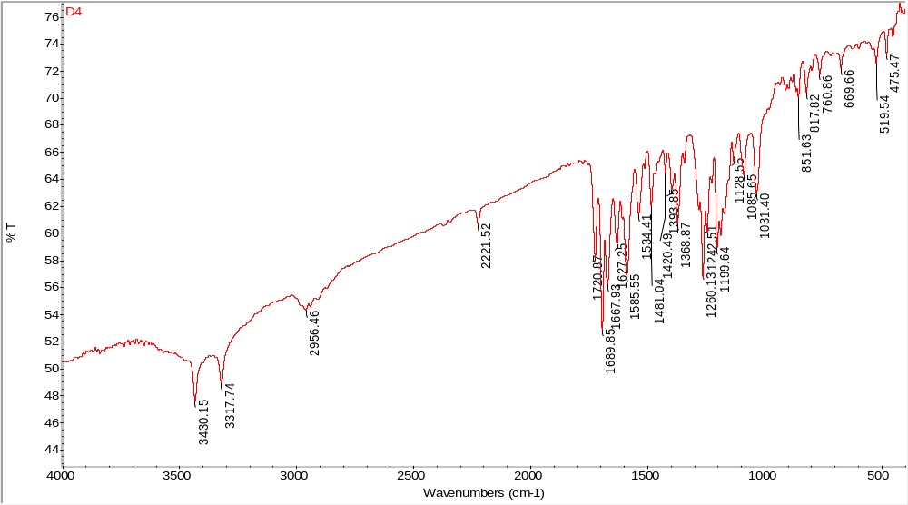
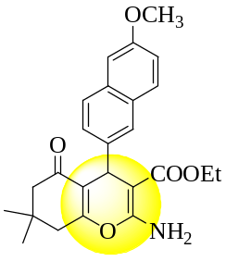

Figure S7: FT-IR spectrum of ethyl-2-amino-4-(6-methoxynaphthalen-2-yl)-7,7-dimethyl-5-oxo-5,6,7,8-tetrahydro-4H-chromene-3-carboxylate (4q)
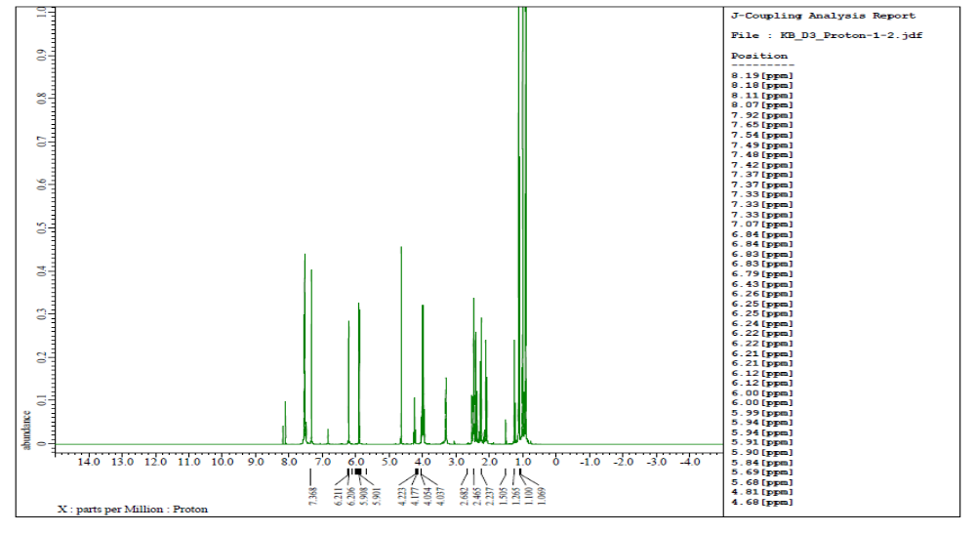
Figure S8: ¹H-NMR spectrum of ethyl-2-amino-4-(6-methoxynaphthalen-2-yl)-7,7-dimethyl-5-oxo-5,6,7,8-tetrahydro-4H-chromene-3-carboxylate (4q)
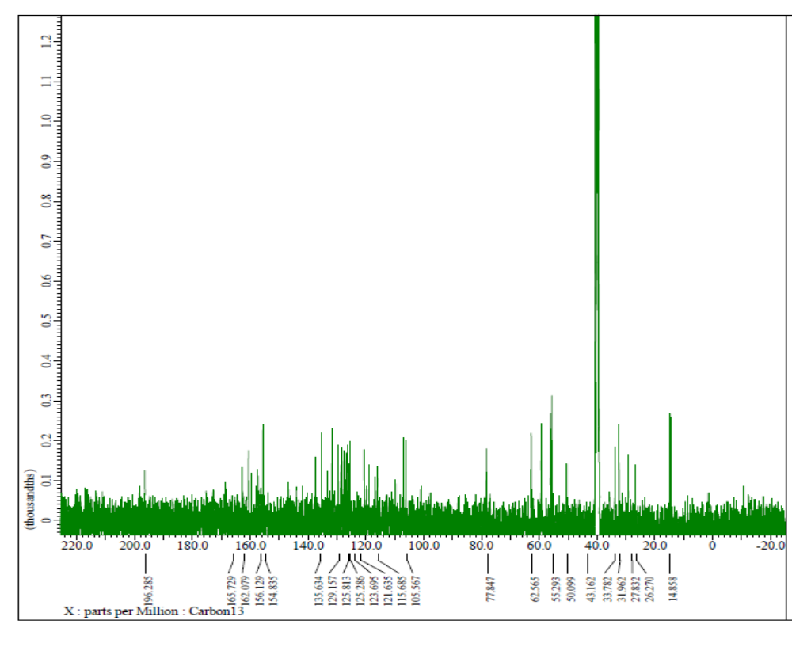

Figure S9: ¹³C-NMR spectrum of of ethyl-2-amino-4-(6-methoxynaphthalen-2-yl)-7,7-dimethyl-5-oxo-5,6,7,8-tetrahydro-4H-chromene-3-carboxylate (4q)

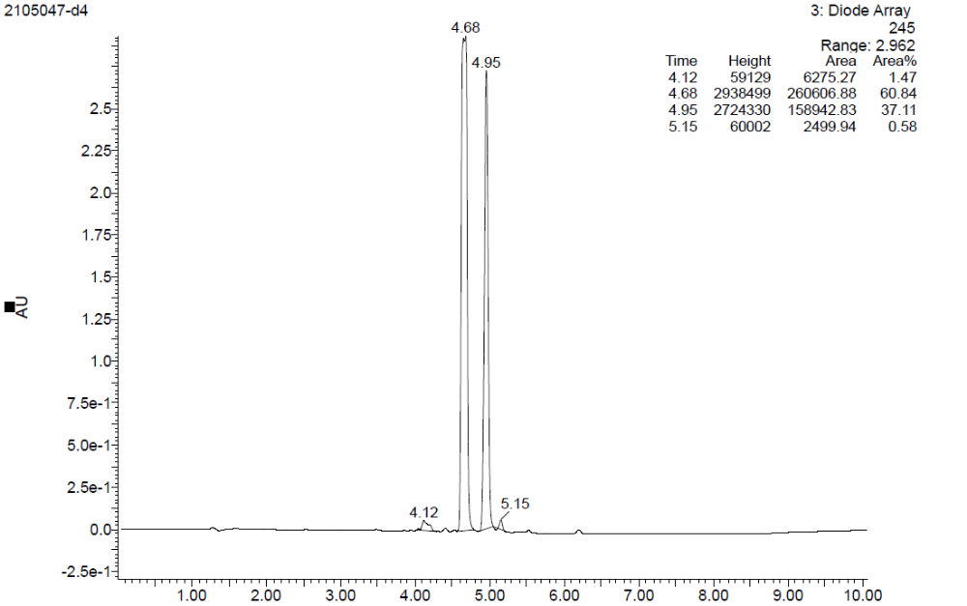

Figure S10: LC profile of ethyl-2-amino-4-(6-methoxynaphthalen-2-yl)-7,7-dimethyl-5-oxo-5,6,7,8-tetrahydro-4H-chromene-3-carboxylate (4q)

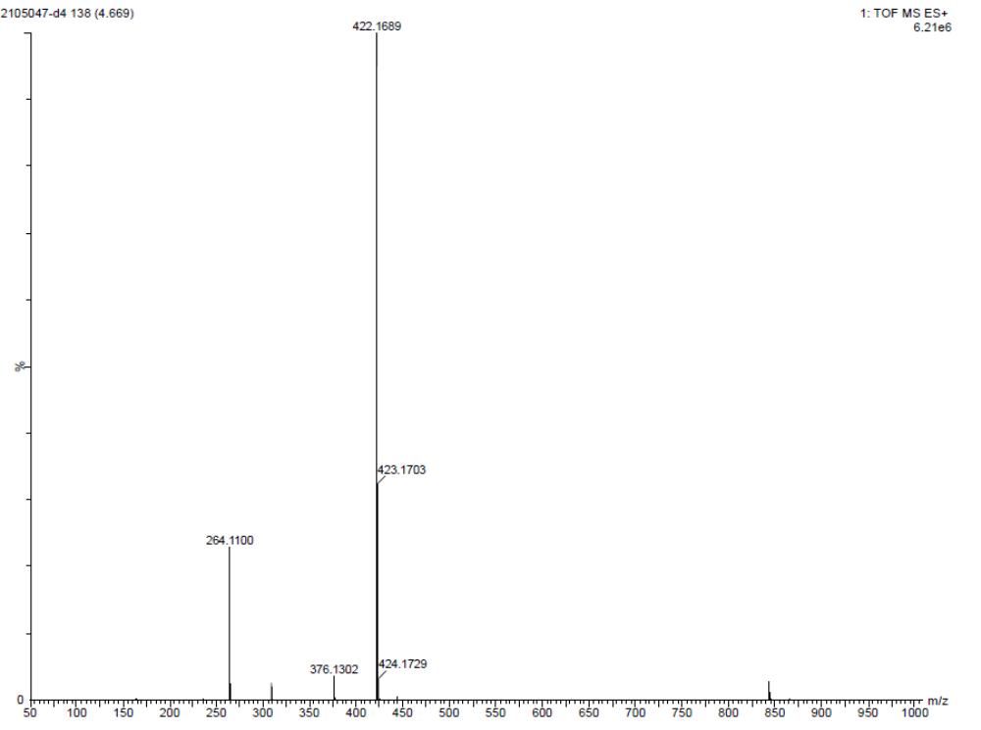
Figure S11: LC-MS spectrum of of ethyl-2-amino-4-(6-methoxynaphthalen-2-yl)-7,7-dimethyl-5-oxo-5,6,7,8-tetrahydro-4H-chromene-3-carboxylate (4q)

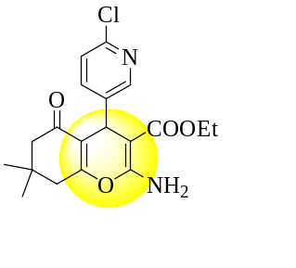
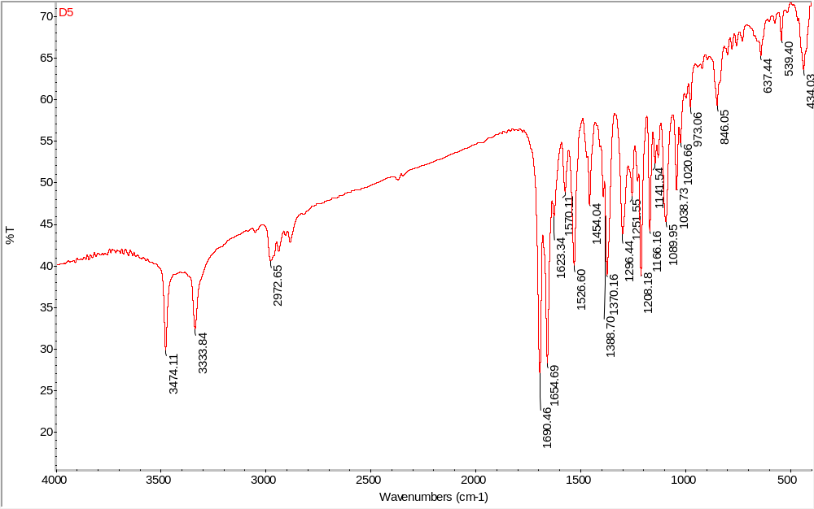

Figure S12: FT-IR spectrum of Ethyl-2-amino-4-(6-chloropyridin-3-yl)-7,7-dimethyl-5-oxo-5,6,7,8-tetrahydro-4H-chromene-3-carboxylate (4r)

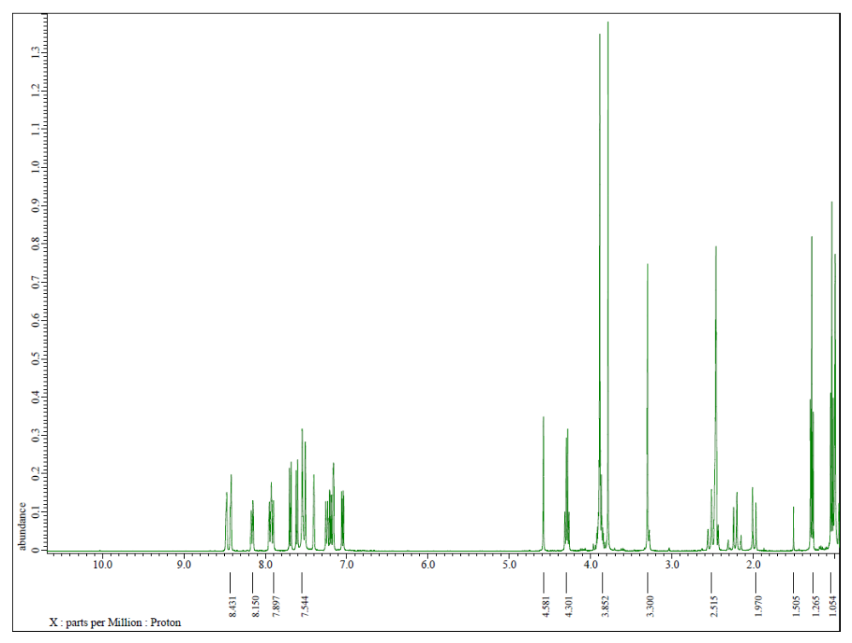
Figure S13: ¹H-NMR (DMSO) spectrum of ethyl-2-amino-4-(6-chloropyridin-3-yl)-7,7-dimethyl-5-oxo-5,6,7,8-tetrahydro-4H-chromene-3-carboxylate (4r)
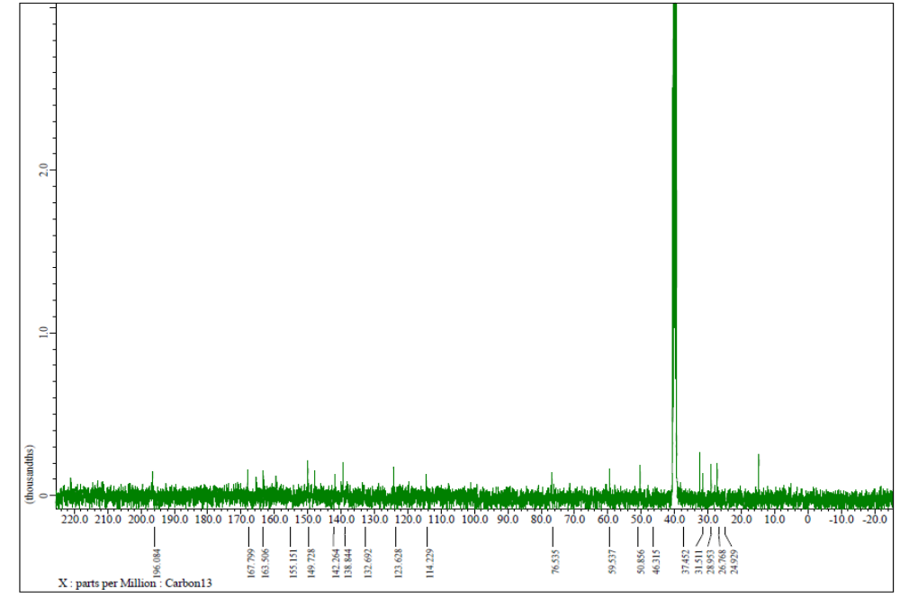
Figure S14: ¹³C-NMR (DMSO) Spectrum of ethyl-2-amino-4-(6-chloropyridin-3-yl)-7,7-dimethyl-5-oxo-5,6,7,8-tetrahydro-4H-chromene-3-carboxylate (4r)

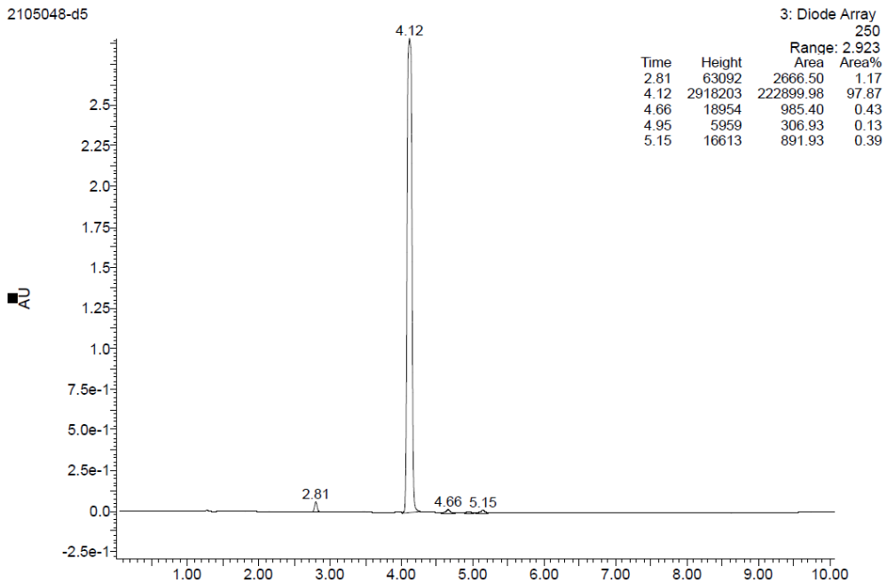
Figure S15: LC profile of ethyl-2-amino-4-(6-chloropyridin-3-yl)-7,7-dimethyl-5-oxo-5,6,7,8-tetrahydro-4H-chromene-3-carboxylate (4r)

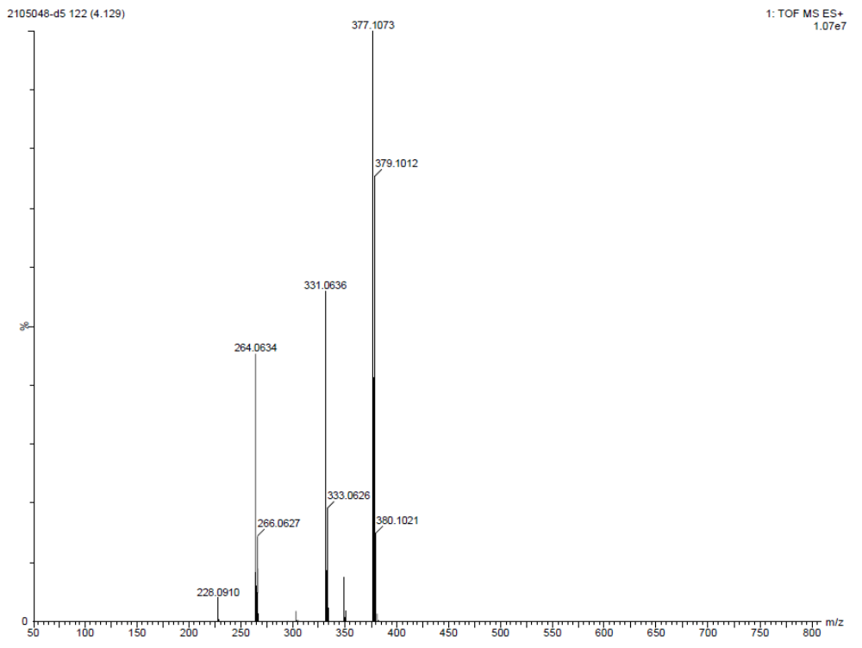
Figure S16: LC-MS spectrum of ethyl-2-amino-4-(6-chloropyridin-3-yl)-7,7-dimethyl-5-oxo-5,6,7,8-tetrahydro-4H-chromene-3-carboxylate (4r)

